**More than meets the eye: serological data reveals widespread circulation of highly pathogenic avian influenza and species-specific response to infection in a Subantarctic wild bird community**

Julia Emerit1,2,*, Augustin Clessin2,3,*, Mathilde Lejeune3, Luca Nelli4, Amanda Kuepfer5, Jérémy Tornos3, Alix Kristiansen6,7, Heather Mathews6,7, Corisande Abiven3, Léo Streith2,4, Teresa Militão8, Edna Correia9, José Pedro Granadeiro9, Katharina Reusch10, Danni Thompson6,11, Louise Pole-Evans12, Alastair Baylis6, Petra Quillfeldt10, Paulo Catry8, Jacob González-Solís13, Thierry Boulinier3, Zoe Fowler14, Amandine Gamble1,4

1 Department of Public & Ecosystem Health, Cornell University, Ithaca, United States

2 École Normale Supérieure de Lyon, Université Claude Bernard Lyon 1, Université de Lyon, Lyon, France

3 Centre d’Ecologie Fonctionnelle et Evolutive, UMR 5175, Université Montpellier, CNRS, EPHE, IRD, Montpellier, France

4 School of Biodiversity, One Health and Veterinary Medicine, University of Glasgow, Glasgow, United Kingdom

5 Falklands Conservation, Stanley, Falkland Islands

6 South Atlantic Environmental Research Institute, Stanley, Falkland Islands

7 School of Life and Environmental Sciences, Deakin University, Melbourne, Sydney

8 Marine and Environmental Sciences Centre, Ispa – Instituto Universitário, Lisbon, Portugal

9 Centro de Estudos do Ambiente e do Mar, Departamento de Biologia Animal, Faculdade de Ciências da Universidade de Lisboa, Lisbon, Portugal

10 Center for International Development and Environmental Research, Justus-Liebig-Universität Gießen, Gießen, Germany

11 School of Biological Sciences, University of Aberdeen, Aberdeen, United Kingdom

12 Saunders Island, Falkland Islands

13 University of Barcelona, Barcelona, Spain

14 Falkland Islands Government, Stanley, Falkland Islands

* These authors contributed equally to this work

Corresponding authors: Julia Emerit ([julia.emerit@ens-lyon.fr](mailto:julia.emerit@ens-lyon.fr)), Amandine Gamble ([amandine.gamble@cornell.edu](mailto:amandine.gamble@cornell.edu))

*Keywords: ###*

*Suggested reviewers:* Sarah Hill, Nicholas Hill, Ralph Vanstreels, Marcy Uhart, Michelle Wille, Megan Craft

*Targeted journals*

* *Nature, Nature Ecology & Evolution* [*https://www.nature.com/nature/for-authors/formatting-guide*](https://www.nature.com/nature/for-authors/formatting-guide)

8-page article with 5-6 modest display items is 4,300 words (Abstract, Main, Results, Discussion, Conclusion) (Amandine’s August version: 5,400 with figure legends)

# Abstract

200 words, with references (Amandine’s July version: 198)

Since 2020, the avian influenza virus (AIV) H5Nx clade 2.3.4.4b has caused the largest highly pathogenic avian influenza (HPAI) outbreak on record1, characterized notably by mortality of seabirds2–4. Yet, the role of wildlife in HPAI dynamics, the impact of HPAI on wildlife, and how they both vary across species remains poorly understood5. Subantarctic ecosystems, with few species gathering in dense colonies, are particularly vulnerable to infectious disease outbreaks6, as well as ideal systems for studying wild species' contributions to pathogen dynamics. We quantified exposure to AIVs in 2,814 samples from 15 wild bird species across subantarctic Falkland Islands. We found evidence of limited AIV circulation before HPAI incursion. After incursion, anti-H5 antibody prevalence reached up to 100% in apex scavengers like gulls, skuas, and striated caracaras, suggesting high exposure and survival of infection, even on islands with no known outbreak. In basal predators like penguins and albatrosses, anti-H5 antibody prevalence remained below 10% despite HPAI-related mortality, indicating limited spread but high infection lethality. This highlights strong heterogeneities in species’ response to HPAI and potential contribution in epizootics driven by their ecology. It also points to apex predators as effective sentinels for tracking HPAI spread via antibody screening.

# Main

The virus responsible for the ongoing highly pathogenic avian influenza (HPAI) panzootic belongs to clade 2.3.4.4b, descending from a lineage thought to have emerged in poultry in China in 1996 as A/goose/Guangdong/1/1996, and circulating in poultry and wildlife since then, with several reemergence events recorded7,8. This lineage has presented as subtype H5Nx – avia influenza virus (AIVs) are classified into subtypes based on their two surface proteins, hemagglutinin (Hx) and neuraminidase (Nx), with HPAI virus presenting as H5Nx or H7Nx, and low-pathogenicity avian influenza (LPAI) virus presenting as any subtype7. This ongoing panzootic is characterized by a particularly wide spread in terms of both affected species and regions5,9. Despite belonging to a lineage classically associated with the Old World, the virus reached North America via both the transatlantic and transpacific routes in late 202110, followed by South America in November 202211, and the (Sub)antarctic region in October 202312. Poultry and wild birds seem to play distinct but entangled roles in the epizoology of the virus, with poultry supporting emergence and maintenance, and wild birds supporting diversification and long-distance spread8,13,14. In its wake, the virus has caused tremendous losses among both domestic and wild animals, although the latter are still likely underestimated5.

Most of our understanding of HPAI dynamics in wildlife comes from opportunistic and/or reactive studies, leading to biases towards specific locations or species, and a likely important underestimation of mortality5. Moreover, most of these studies are based on fatal case detection only, leading to a likely underestimation of actual incidence, which should also consider individuals who survived infection15. The rare studies including live birds suggest that infected birds can recover from infection while developing immunity against the virus4,16,17. The lack of studies considering live birds has thus led to an important knowledge gap regarding the extent of the epizootic at both the individual and species levels. This limits our understanding of heterogeneity in susceptibility and resistance to HPAI infection, and subsequently of the contribution of different wild bird species to HPAI dynamics. Filling this gap would broaden the understanding of this epizootic and could help focus surveillance and mitigation efforts.

Insular ecosystems represent ideal models to study infectious disease dynamics in wildlife communities. Oceanic islands provide unique opportunities to track the dynamics of a pathogen in relatively closed systems that can be exhaustively studied. In particular, subpolar islands, which harbour large and dense wild populations from relatively few species18, together with little or no domestic populations, represent unique opportunities to simultaneously study a large proportion of all the species potentially involved in the dynamics of the pathogen of interest. Marine birds and mammals occupying subantarctic islands breed in dense colonies, where pathogens can quickly spread6,19, and have been particularly affected by HPAI2–4,20. In these long-lived species, adult mortality can have severe long-term impacts on population dynamics21. Reciprocally, these species, in which prevalence can be high, also likely play important roles in the ecology of the virus, for instance by contributing to long-distance spread22. Such systems are thus relevant to improving our understanding of HPAI ecology in wild birds.

The (Sub)antarctic region remained free of HPAI until October 2023, with no evidence of disease reported during the 2022/2023 Austral summer despite high surveillance efforts23,24. In 2023/2024, in the context of the southward spread of HPAI, the Falkland Islands (51°43’S, 59°25’W; **Figure 1a**; hereafter referred to as “Falklands”), located at the crossroad between South America and Antarctica, represented a strategic place for virus surveillance in the (Sub)antarctic region25. The archipelago is also of great biodiversity conservation interest itself as it hosts 21 several important bird populations, including important populations of southern rockhopper penguins (*Eudyptes chrysocome*) and striated caracaras (*Phalcoboenus australis)* listed on the IUCN Red List26, as well as two endemic species and 13 endemic sub-species26,27.

In October 2023, the first HPAI case was detected in the Falklands when a dead southern fulmar (*Fulmarus glacialoides*) tested positive for H5N1 by polymerase chain reaction (PCR)23, which was later confirmed as HPAI H5Nx clade 2.3.4.4b by sequencing12, as part of the surveillance program implemented by the Falkland Islands Government (FIG), consisting of AIV RNA screening and characterization from dead and symptomatic birds reported by the community. Over the rest of the breeding season, this program detected ten sporadic cases and three outbreaks (i.e., cluster of cases with evidence of local transmission such as increasing numbers of dead animals) across the archipelago (**Figure 1a**)28. The Steeple Jason outbreak seemed to primarily have affected black-browed albatrosses (*Thalassarche melanophris)*, and marginally rockhopper penguins and brown skuas (*Stercorarius antarcticus*), and the Sealion Island and Carcass Island outbreaks to have primarily affected gentoo penguins (*Pygoscelis papua*)28.

In order to better understand the actual extent of H5Nx circulation in the system, the associated impact on wildlife, and the potential contribution of different species to the dynamics of the virus, we investigated exposure to AIVs in birds sampled across the Falklands before and after the incursion of HPAI H5N1 via specific antibody screening. We assessed: (i) the potential for pre-existing exposure to and immunity against AIVs, considering the circulation of LPAI in the (Sub)antarctic region29–33; (ii) the actual extent of exposure, which cannot be captured by dead or symptomatic bird screening only given expected non-fatal infections in wildlife4,16; and (iii), heterogeneities in exposure across species and sites, hypothesizing that species breeding in high densities would show high level of exposure around outbreak epicenters, and that species scavenging on other AIV hosts would be more exposed than other species, especially on islands experiencing outbreaks and, to a lesser extent, sporadic cases (**Figure 1-Figure 2**). In addition to addressing these questions, antibody prevalence data was expected to enrich our understanding of (iv) the lethality of HPAI infection, how it varies across populations, and potential implications for virus spread by asymptomatic individuals, and (v) the potential for acquired immunity and potential implications for future HPAI outbreaks. Altogether, this study provides key insights to understanding the mechanisms of HPAI spread and its impact on wild bird populations. By enhancing our understanding of viral dynamics, exposure patterns, and species-specific vulnerabilities, we can better inform and optimize future surveillance, mitigation, and conservation strategies to protect biodiversity and ecosystem health.

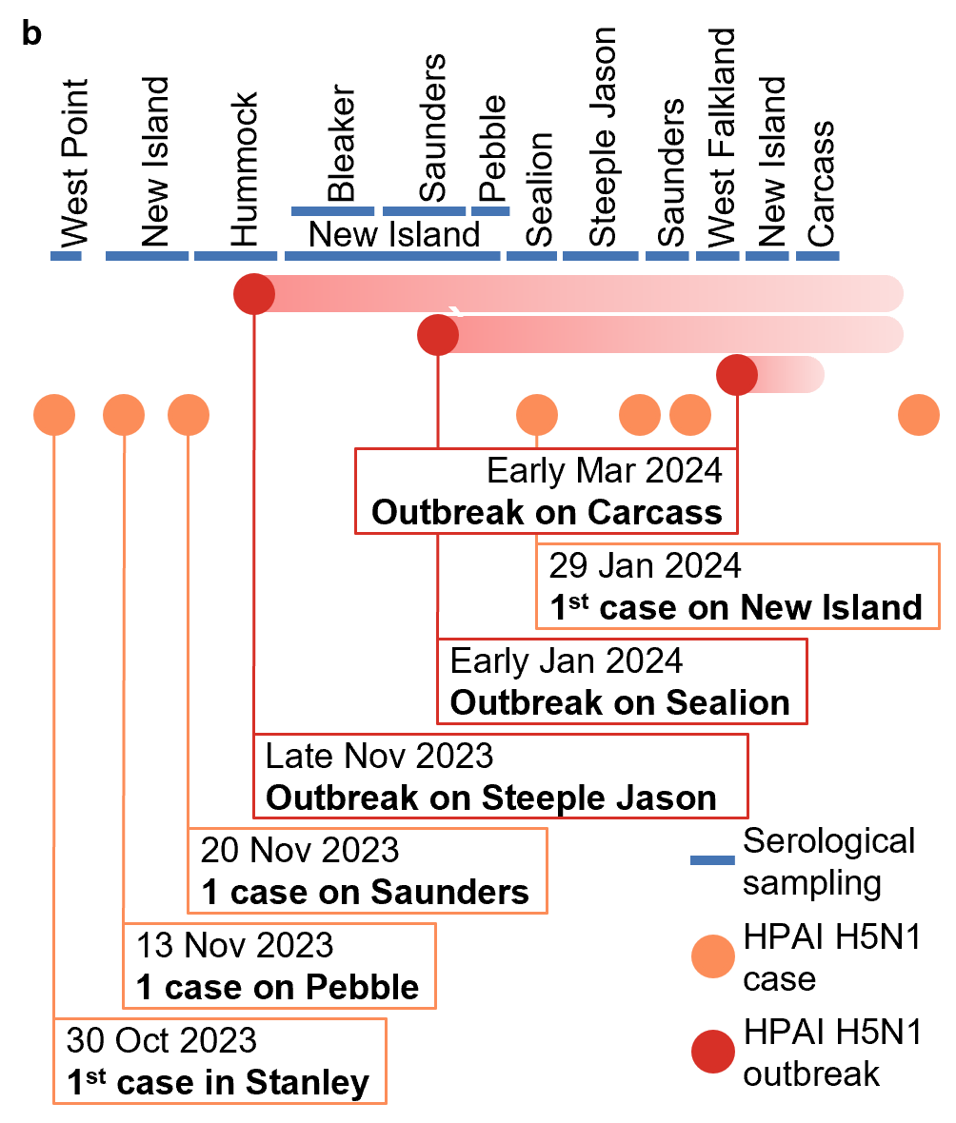

**Figure 1. Overview of the HPAI investigation in the Falklands.** **a.** Map of sampled sites during seasons 2022/2023 and 2023/2024; confirmed HPAI H5N1 cases or outbreaks are reported. **b.** Chronology of visited sites during the 2023/2024 season with dates of report of the main cases of HPAI. The first case was detected after the beginning of the sampling season.

# Results

For our investigation, we targeted 15 species categorized into three groups based on their ecological traits relevant to HPAI exposure risks (**Figure 2**), representing the large majority of the avian biomass of the Falklands. For marine *meso predators* (albatrosses, prions, penguins and shags), which breed in colonies on land and feed on marine organisms at sea, we expected strong spatial structuration of exposure to H5Nx, with high exposure levels in patches subject to HPAI outbreaks, but low exposure levels otherwise. For *anatids* (ducks and geese), which occupy scattered territories and feed on plants and algae on land and along the coast, we expected overall low exposure levels, with only individuals occupying territories close to affected basal predator colonies being exposed. Finally, for *apex predators* (giant petrels, skuas, gulls, sheathbills and striated caracaras), which feed and notably scavenge on the two other categories, we expected overall high levels of exposure, especially on affected islands. We sampled these species both before and after the detected incursion of HPAI in the archipelago (before: summers 2012/2013, 2017/2018, 2018/2019 and 2022/2023; after: summer 2023/2024), and from 14 islands over the archipelago, including sites with and without recorded cases (**Figure 1a-b**). We analysed a total of 2,814 blood samples, for which we assessed the presence of antibodies against AIVs in general and H5 in particular as markers of exposure using commercial competitive enzyme-linked immunosorbent assays (ELISAs) targeting antibodies against the virus nucleoprotein or H5 hemagglutinin respectively. All sampled individuals were apparently healthy at the time of sampling, except for two gentoo penguin chicks sampled during the HPAI outbreak of Sealion Island (south-east of the archipelago, **Figure 1a**).

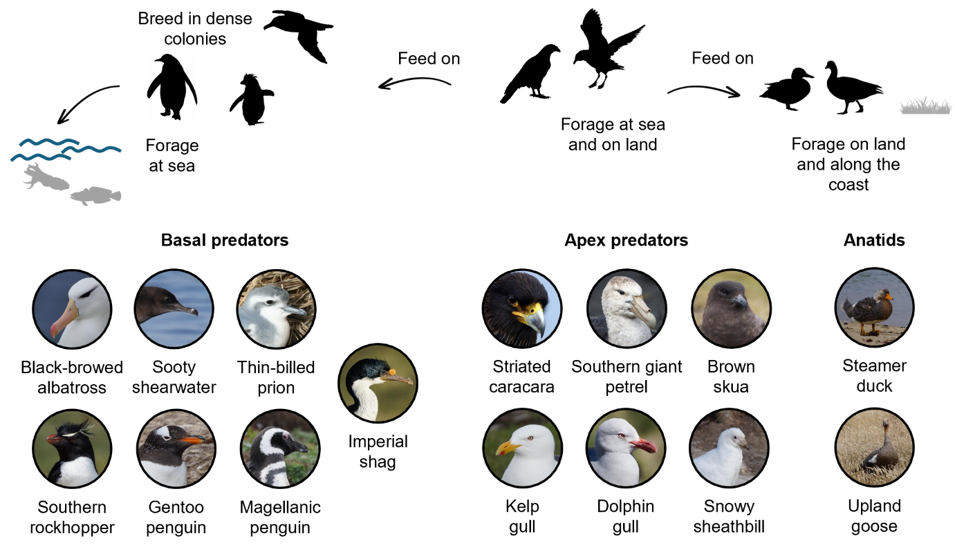

**Figure 2. Simplified ecological classification and interactions across the sampled species.** *Apex predators* includedstriated caracaras (*Phalcoboenus australis*), giant petrels (southern giant petrels, M*acronectes giganteus*), skuas (brown skuas, *Stercorarius antarcticus*), kelps gulls (*Larus dominicanus)*, dolphin gulls (*Leucophaeus scoresbii)*, sheathbills (snowy sheathbills, *Chionis albus*). *Meso predators* included albatrosses (black-browed albatrosses, *Thalassarche melanophris*), shearwaters (sooty shearwater, *Ardenna grisea*), prions (thin-billed prions, *Pachyptila belcheri),* imperial shags (*Leucocarbo atriceps*), southern rockhopper penguins (*Eudyptes chrysocome*), gentoo penguin*s* (*Pygoscelis papua*) and Magellanic penguins (*Spheniscus magellanicus*). *Anatids* included steamer ducks (Falkland steamer ducks, *Tachyeres brachypterus*) and upland geese (*Chloephaga picta*). Picture copyrights: eBird (shearwater and prion) and Amandine Gamble (all other species).

## Exposure to H5Nx after HPAI incursion

Prior to 2023/2024 (before the first HPAI H5N1 case detection), both AIV and H5 seroprevalences (i.e., proportion of antibody positive individuals) were overall low (**Figure 3**, **Extended Data Figure 1**-**Extended Data Figure 2**). Five species showed evidence of exposure to non-H5 AIVs, with AIV seroprevalences in adults reaching a maximum of 55 [31, 77] % in apex predator species (striated caracaras and skuas) and up to 33 [12, 62] % in meso predator species (albatrosses, rockhopper penguins and Magellanic penguins), and H5 seroprevalence being below 13 [2, 41] %. Steamer ducks showed evidence of high-level exposure to H5 with all six sampled individuals seropositive for H5. The four other sampled species showed no evidence of exposure to AIVs.

In 2023/2024 (year of the first HPAI H5N1 case detection12,23), we found evidence of broad H5Nx circulation in the system (**Figure 3**, **Extended Data Figure 2**), especially in apex predators, with H5 seroprevalences in adults reaching up to 100 [79; 100] %. In meso predator species, H5 seroprevalences in adults remained low, reaching a maximum of 6.66 [0.17, 31.95] %. In anatids, steamer ducks showed again evidence of high-level exposure to H5 with 30/37 sampled individuals seropositive for H5 spread over three islands; in contrast, upland geese showed no evidence of exposure to H5. On New Island (west of the archipelago), after adults of several species had been found for several years with consistently low H5 seroprevalences, H5 seroprevalences suddenly rose in 2023/2024 in apex predators (striated caracaras and skuas; **Extended Data Figure 3**). This rise was accompanied by a rise in AIV seroprevalences in chicks (but not adults) in albatrosses (**Extended Data Figure 4**).

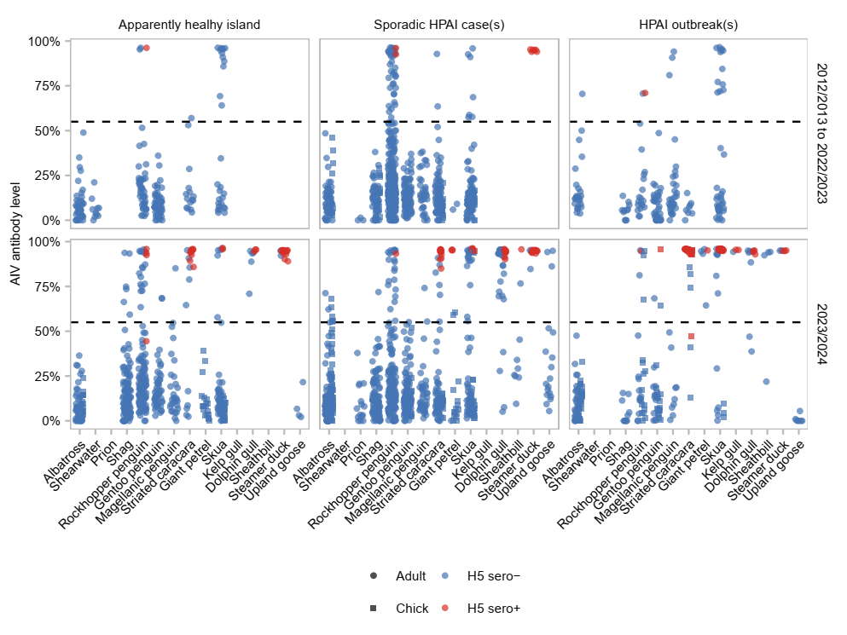

**Figure 3. Anti-AIV and anti-H5 antibody detection patterns in adult birds of the Falklands across species ecological categories and islands epidemiological statuses before and after HPAI incursion.** Each point represents a sample, with position on the y-axis representing anti-AIV antibody level (from low to high), and colour representing the anti-H5 antibody status (negative or positive, based on the H5 serostatuses reconstructed by integrating the observed data on anti-AIV antibody detection and partially observed data on anti-H5 antibody detection). The horizontal dashed line indicates the positivity threshold for anti-AIV antibody detection.

## Heterogeneity in exposure and lethality

To gain insights on hosts’ responses to exposure to HPAI H5Nx, we investigated H5 seroprevalence in individuals sampled in proximity to ongoing outbreaks.

We visited Steeple Jason (north-west of the archipelago) in January 2024, approximately two months after the first cases were reported on the island (**Figure 1**). Albatrosses, rockhopper penguins, and, to a lesser extent, skuas were found dead during this outbreak. The other species present on the island did not show signs of HPAI. In meso predators, H5 seroprevalences in adults remained below 7 [0, 32] % (**Extended Data Figure 2**); in particular, despite high mortality and confirmed cases being reported in this albatross colony23, none of the 30 adults and 30 chicks was seropositive for H5 (**Figure 4**). Almost all the sampled apex predator individuals (44/50) were seropositive for H5 despite no (striated caracaras) to low (skuas) mortality being reported in these species. Among the six H5 seronegative individuals, one adult skua and three striated caracara chicks were seropositive for AIVs only, while two striated caracara chicks were seronegative for both. Both species were seen scavenging on carrion in albatross colonies affected by H5N1 HPAI (**Extended Data Figure 5**).

**Figure 4. Description of Steeple Jason Island HPAI outbreak.** Combined AIV and H5 serostatuses for meso predators (albatrosses and rockhopper penguins) and apex predators (striated caracaras and skuas) in 2022/2023 and in 2023/2024 (year of the first HPAI H5N1 incursion). Only species sampled both years are represented. Each point represents a sample at its collection location. Crosses indicate where clusters of dead birds (albatrosses, rockhopper penguins, gentoo penguins and skuas) were observed.

We visited Sealion Island (south-east of the archipelago) in January 2024, approximately two weeks after the first mortalities in the gentoo penguin colony were observed (**Figure 1**). In meso predators, only one of the 22 gentoo penguins sampled in the colony affected by HPAI was seropositive for AIV and H5, and two for AIV only (**Extended Data Figure 6**). The three individuals with AIV antibodies included the two chicks that showed symptoms compatible with HPAI (loss of coordination and balance for one and vasculitis oedema for the other) at the time of sampling. About half (22/46) of the apex predator individuals were seropositive for H5, among which all nine striated caracaras; in the other apex predator species, H5 seroprevalences in adults ranged from 0 [0, 60] to 66 [9, 99] % (**Extended Data Figure 2**).

The patterns observed on Steeple Jason and Sealion Islands were observed more broadly at the scale of the whole archipelago. H5 seroprevalence in meso predators remained low independently of the HPAI H5N1 situation. In apex predators however, it increased in 2023/2024 (year of the first HPAI H5N1 case detection), especially on islands where HPAI H5N1 outbreaks were recorded (**Figure 5**).

**Figure 5. H5 seroprevalences in birds of the Falklands across species ecological categories and islands epidemiological statuses.** Seroprevalences ± 95% credible intervals were calculated as the proportion of samples positive for anti-H5 antibodies within a given population of adult birds. To facilitate comparison and interpretation of the results, we only considered birds from species that were sampled both before 2023/2024 and in 2023/2024.

## Archipelago-wide scale circulation of H5Nx

To gain insights on the extent of HPAI H5Nx circulation in the archipelago, we investigated H5 seroprevalence in islands with no known outbreaks. Seropositive apex predators were scattered throughout the archipelago, including on islands with no known outbreaks or sporadic case(s) only (**Figure 3**- **Figure 5** and **Extended Data Figure 7**).

## Timing of H5Nx exposure

H5-seropositive apex predators were detected as early as the 23rd of October 2023 (i.e., before the first confirmed case in the Falklands; **Figure 1b**) – this seropositive striated caracara was sampled on New Island, where the first locally confirmed case was detected in January 2024.

To gain further insights on individuals’ timing of exposure to HPAI H5Nx and other AIVs, we investigated H5 and AIV serostatuses of marked birds. In total, 32 marked individuals were recaptured on islands west of the archipelago (**Figure 1a**). Among the individuals recaptured in 2023/2024, seroconversion was observed in 7 individuals for AIVs and 8 individuals for H5 (**Figure 6**). On Steeple Jason, 5/5 recaptured skuas seroconverted between 2022/2023 and 2023/2024. On New Island, 2/8 skuas seroconverted: one between December 2022 and December 2023, and one between November and December 2023.

Complementary information on timing was provided by detecting 11/285 chicks seropositive for H5: the symptomatic gentoo penguin from Sealion Island, 9 striated caracaras from Steeple Jason, where an H5N1 HPAI outbreak was affecting albatrosses, and one skua from New Island where other skua chicks have tested positive for HPAI H5N1 by PCR. All those chicks were at least one month old. General AIV seroprevalence in chicks was higher with 27/285 seropositive chicks. In addition to gentoo penguins, striated caracaras and skuas, this included albatrosses, rockhopper penguins and giant petrels.

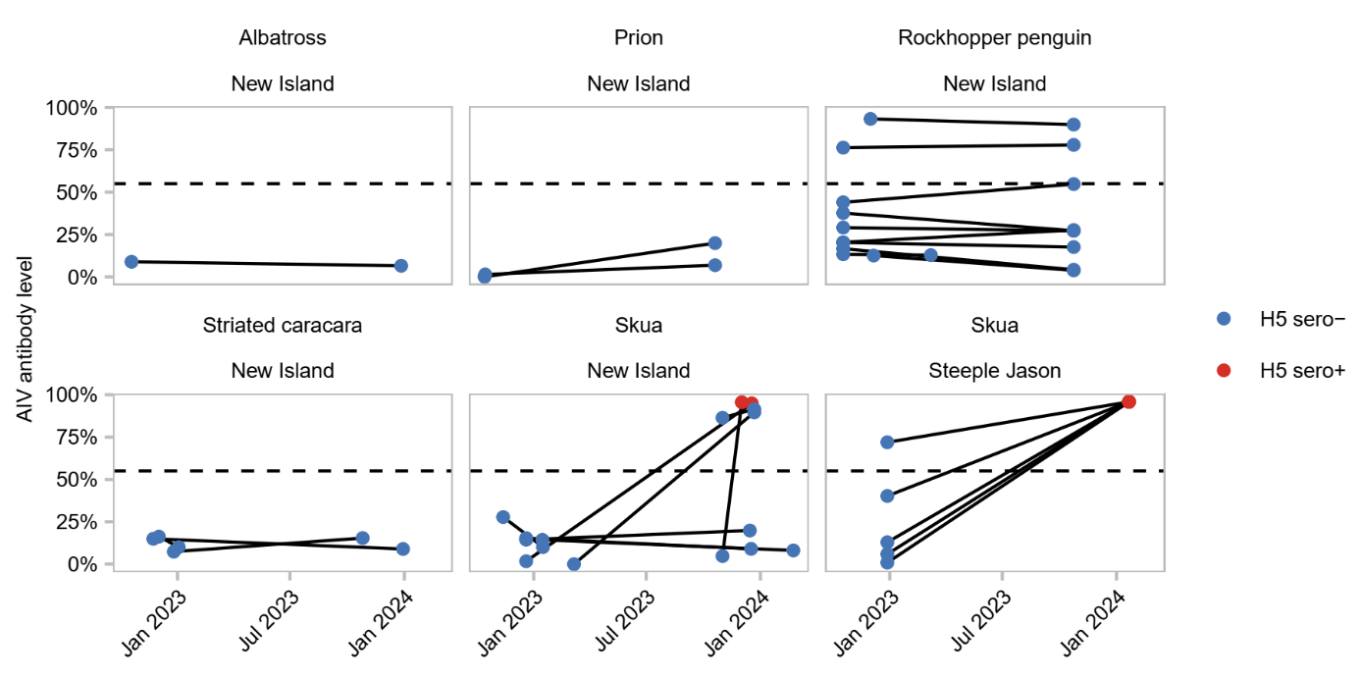

**Figure 6. Anti-AIV and anti-H5 antibody detection across time in marked birds.** Each point represents a sample, with position on the y-axis representing anti-AIV antibody level (from low to high), and colour representing the anti-H5 antibody status (negative or positive, based on the H5 serostatuses reconstructed by integrating the observed data on anti-AIV antibody detection and partially observed data on anti-H5 antibody detection). Only islands where at least two individuals were recaptured and only the 2022/2023 to 2023/2024 data are shown. Black lines connect samples collected from the same individual. The horizontal dashed line indicates the positivity threshold for anti-AIV antibody detection.

Finally, to gain insights on the site of exposure (within *vs* outside of the Falklands), we compared monthly H5 seroprevalences of two species for which sampling covered the whole breeding season, but with contrasted migratory behaviours: striated caracaras, which are year-long resident of the archipelago, and skuas, which migrate northward during the Austral winter. In both species, H5 seroprevalence was null before 2023/2024. In 2023/2024, H5 seroprevalence rose first in striated caracaras (the resident species) with seropositive birds detected as early as October 2023, then in skuas (the migratory species) two months later in December 2023 (**Extended Data Figure 8**). For apex predators, exposure outside of the Falklands does not seem more likely than exposure within the Falklands.

# Discussion

Based on an extensive, ecologically informed serosurvey of AIVs in a wildlife community, we show a much wider extent of H5Nx circulation than expected from symptomatic or fatal case detection only, and strong heterogeneities across species in their exposure patterns and response to infection. We notably report evidence of exposure to H5Nx in six more species (dolphin gull, kelp gull, sheathbill, giant petrel, striated caracara, and steamer duck) than the seven detected through case surveillance23,28, and contrasted seroprevalences ranging from 0% in most meso predator populations to 100% in several apex predator populations. These findings highlight a complex epidemiological system, involving many species with markedly different responses and potential contributions to H5Nx circulation, which is critical to include in surveillance protocols and risk assessments.

## Interpretation of serological data

Both LPAI29–33 and H5Nx HPAI12,23,34 viruses have been detected in the (Sub)antarctic region over the last decades and could be circulating in the Falklands. ELISAs do not enable to discriminate between the two due to cross-reactivity between H5 variants. In our case, several pieces of evidence suggest that the detection of anti-H5 antibodies informs on H5Nx HPAI circulation in the system. Including samples collected over several years, notably recaptures of marked individuals, allowed us to detect in several species a dramatic rise in exposure to H5Nx in summer 2023/2024, coinciding with the timing of H5N1 HPAI incursion as supported by epidemiological observations (high mortality and compatible symptoms affecting various species) and sequencing data12, and aligning with the epizootic nature of HPAI outbreaks.

Prior to summer 2023/2024 and H5N1 HPAI incursion, circulation of AIVs, and H5Nx in particular, seemed limited. Only steamer ducks, and few rockhopper penguins showed evidence of exposure to H5Nx. For steamer ducks, the widespread detection of anti-H5 antibodies across the archipelago and the lack of recent PCR-positive cases suggest that exposure to H5Nx likely predates the emergence of HPAI H5Nx clade 2.3.4.4b and likely involve LPAI viruses. The circulation of this or those LPAIH5Nx seems limited to this species as prevalence of anti-H5 antibodies in all the other species, including other winter resident such as striated caracaras and upland geese, was low to null before summer 2023/2024

As antibodies can be detectable for months after exposure35, it is not obvious when the birds were exposed, and where they were when they were exposed. However, exposure of steamer ducks to H5Nx necessarily happened locally as this species does not migrate out of the archipelago, and the majority of the population is actually flightless. On the contrary, exposure of rockhopper penguins, albatrosses, giant petrels and skuas to H5Nx and other AIVs could have happened out of the archipelago during their winter migration31,36,37; it is less clear for gulls and sheathbills, whose movement ecology is understudied. In any case, the detection of anti-H5 antibodies in months-old chicks near HPAI cases suggests recent exposure and the detection of endogenous antibodies, rather than maternal antibodies38. Those observations confirm the circulation of H5Nx in the Falklands in 2023/2024 and demonstrates the effectiveness of antibody screening for its detection.

Finally, the detection of AIV-seropositive but H5-seronegative individuals, especially chicks, in contexts of likely recent exposure to HPAI H5Nx (e.g., penguin chicks in an affected colony and apex predators in close proximity to affected colonies) suggests that our AIV assay might detect antibodies earlier in the immune response that our H5 assay. This could be explained by differences in sensitivity and would indicate an even wider circulation of H5Nx in the system than indicated by H5 seroprevalences only (e.g., including the albatross colonies of New Island). However, considering the circulation of AIVs in the (Sub)antarctic region prior to HPAIN 2.3.4.4b emergence39, we preferred to keep a conservative positivity threshold for our H5 assay. Altogether however, this highlights the need to use complementary tests to overcome potential test-sensitivity issues.

## Insight on exposure and survival

The observed contrasts in seroprevalences across species suggests strong heterogeneities in H5Nx exposure and lethality. On one hand, meso predators seem to die before being about to mount a detectable immune response. Their exposure rate could thus be estimated directly from their mortality rate. On the other hand, apex predators seem to generally survive infection at least long enough to mount a detectable immune response. Notably, two months after the detection of the HPAI outbreak on Steeple Jason, we did not find any dead or symptomatic striated caracaras, yet all the sampled adults had antibodies against H5, indicating that they can survive infection over several months, potentially by clearing it. Their exposure rate is thus better estimated through antibody prevalence. Overall, this hints to very high lethality of infection but low exposure rate of meso predators to H5Nx, except on three islands affected by outbreaks, and low lethality of infection but very high exposure rate of apex predators to H5Nx all over the archipelago.

High exposure of apex predators, notably birds of prey and other scavengers, was also observed in Europe and North America40, and, closer to the Falklands, in South Georgia12 and on the Antarctic Peninsula34. However, in Europe and Antarctica, outbreaks were associated with high mortality in skuas (*Stercorarius* spp.)20,34, contrasting with our observations in the Falklands. Hence, even though host phylogenetic proximity can be a good predictor of response to infection in some contexts41, taxon-level inference is not enough to fully understand HPAI dynamics in wild communities.

Within the Falklands, the contrasted impact of HPAI on albatrosses (low exposure, high lethality) *versus* giant petrels (high exposure, low lethality) points towards ecological drivers rather than a phylogenetic effect on the response of species to HPAI. Indeed, both species belong to the *Procellariiformes* order, however, they have contrasted ecologies, notably regarding their foraging behaviours. Black-browed albatrosses exclusively forage at sea, on marine organisms. Giant petrels forage both at sea and inland, and frequently scavenge on other marine predators such as penguins and elephant seals, which could represent a source of infection of AIVs.

Similarly, within the *Anatidae* family, we observed contrasted patterns between steamer ducks and upland geese. Anatids have historically been considered reservoirs of AIVs, notably HPAI7. These species are usually considered to tolerate infection, and are thought to contribute to transmission to other species42. In this context, anatids in the Falklands were under high surveillance by the FIG surveillance program and our research team. Both steamer ducks and upland geese seemed unimpacted by H5N1 HPAI after its incursion to the archipelago. However, steamer ducks appeared to have been widely exposed to a likely LPAI H5Nx, likely prior to H5N1 HPAI incursion, while upland geese did not show any sign of exposure to H5Nx. Nevertheless, because they are abundant and widespread over the archipelago, form dense aggregations in winter, and forage close to both seabird colonies and human settlements in summer, both species remain a major concern regarding their potential as maintenance and/or bridge host of HPAI in the Falklands.

## Insight on transmission and spread

Following H5N1 HPAI incursion, only three outbreaks and ten sporadic cases were detected in the Falklands23, indicating that HPAI circulation was relatively confined, especially compared with the outbreaks recorded in Europe in terns and gannets, which rapidly spread through the whole meta-populations3,4. However, our serological data reveals that H5Nx circulated much more broadly in the system. In particular, apex predators were highly and widely exposed to H5Nx, pointing towards scavenging as a key transmission route.

The detection of many exposed, and potentially infected, apex predators on apparently healthy islands suggests that onward transmission from apex predators to other species was relatively limited and/or that many transmission chains faded out before being detected. This is also supported by the ten sporadic cases, which were mostly detected in apex predators (four in skuas and two in birds of prey)23, that failed to spark outbreaks. Hence, although it is often suggested that apex predators like skuas and gulls could be key spreaders of HPAI, our data suggest that it did not happen that often in the Falklands. Moreover, it may happen less and less often as these species gain immunity against circulating HPAI lineages, reducing their susceptibility to, and competence for, the virus as observed in experimentally infected waterfowl35,43. In addition, apex predators also participate in carcass removal, which can reduce infection pressure in a system44, and is notably suspected to have mitigated HPAI spread in tern colonies in Europe3. It is thus not obvious whether apex predators drive or limit HPAI spread, and any statement should carefully consider existing evidence regarding their disease ecology, movement ecology and foraging ecology, which are for now seriously limited, especially compared to more emblematic species such as penguins and albatrosses.

The detection of seropositive birds on an apparently healthy island raises several – non mutually exclusive – potential explanations. (1) Other cases could have been missed, which is likely to happen to a certain extent. The subtle increase in AIV seroprevalences observed in apparently healthy colonies of New Island for instance could be an indication of recent exposure to H5Nx and undetected low-level mortality. However, it is unlikely for large outbreaks to be missed, especially considering the high observation effort from inhabitants and tourists scattered across the archipelago all summer. (2) These birds could have been exposed somewhere else as antibodies remain detectable several months after exposure35. This is very unlikely for striated caracaras, which are year-round residents of the archipelago, and rarely move between islands during the breeding season45. It is plausible for skuas though, as they often travel across islands to forage46. They also migrate out the archipelago during winter37, but we did not find evidence that skuas had been exposed to H5Nx during their winter migration and that they could have brought the virus back to the island at the beginning of the 2023/2024 breeding season. (3) These birds could have been exposed by scavenging on floating carcasses, which are easy to miss, as most of the apex predators forage both inland and at sea, as suggested for an avian cholera outbreak in the North Atlantic in the past47. Hence, although at-sea pathogen transmission has historically been considered limited compared to transmission within the dense coastal colonies in which seabirds gather to breed19, potential for at-sea transmission of HPAI should not be neglected.

A plausible scenario to explain the observed patterns is that mesol predators introduce HPAI to the region through migratory movements, massively happening in early summer when the first seropositive individuals were detected, and/or foraging movements, happening all summer long, between South America, where it was introduced from12, and the Falklands48. Apex predators then could act as epidemiological bridges, linking offshore cases with dense coastal colonies, and potentially colonies to one-another through their foraging behaviours. Most of these cases likely fail to initiate sustained transmission chains, but a few do, leading to large outbreaks in meso predator colonies. In this context, the removal of potentially infected carcasses before they contribute to onward transmission could help reduce even more the number of outbreaks.

## Immunity and future outbreaks

We found evidence of limited circulation of AIVs, including H5Nx subtypes, in the Falklands before 2023/2024. Hence, overall, local wildlife likely had little to no immune protection against HPAI. Exposure to different Hx subtypes can provide varying levels of cross-protection against HPAI depending on the subtype combinations35,43. Both H5- and AIV-seropositive individuals could thus have had some partial protection against H5Nx HPAI. These individuals were primarily steamer ducks, with high H5-seroprevalence, and rockhopper penguins and skuas, with low AIV-seroprevalences. These species, despite breeding or foraging near colonies of albatrosses and gentoo penguins impacted by H5Nx HPAI, experienced only minor or no mortality.

Other factors than adaptive immunity have to explain the observed heterogeneity across species in mortality though, as, for instance, the striated caracara population was completely naïve before HPAI incursion yet it did not experience any HPAI-related mortality. In apex predators, which all scavenge, these factors could consist in adaptations to carrion eating, such as innate immunity or chemical defences49.

Considering the observed H5-seroprevalences at the end of summer 2023/2024, we can expect strong heterogeneities across species in immune protection against potential future HPAI outbreaks. Apex predators exhibited high seroprevalences and could be protected, leading to lower mortality in the affected species such as skuas. For instance, in Canada, seabirds had significantly less mortality in the second season with HPAI50. On the contrary, meso predators seem to have acquired little immunity and may be severely impacted again in case of future HPAI outbreaks.

## Implication for future surveillance

Most of the current HPAI panzootic surveillance in wildlife has been based on PCR screening (e.g., see51). PCR screening can precisely identify pathogens and inform on infectious status at the time of sampling, but only detects pathogens during their often-brief infectious period. As a result, PCR screening on its own can lead to underestimated incidence rates or even missed outbreaks. When focused on dead animals in particular, it biases detection towards lethal cases, leading to overestimated cate-fatality rates, and neglecting individuals surviving infection despite the critical role they can play in pathogen spread. In contrast, antibodies persist for months after infection35, providing a longer detection window and enabling the identification of outbreaks that PCR might miss. Hence, although serological data can be challenging to interpret52, they prove valuable for detecting present or past outbreaks (e.g., see53), assessing outbreak extents, and understanding host survival4,16 and transmission pathways17, as also recently demonstrated in humans54.

In the Falklands, antibody screening of apex predators prove particularly efficient to track H5Nx dynamics, these species thus representing excellent sentinel species55. These species showed high AIV- and H5-seroprevalences after H5Nx HPAI incursion in the Falklands, including on islands with no known outbreak or case, potentially revealing missed and/or offshore cases. In particular, we detected the first H5-seropositive striated caracara a week before the first detected H5N1 HPAI case. This raises the question of the actual date of HPAI introduction in the Falklands, suggesting it was likely earlier than thought.

Striated caracaras are abundant and widespread across the Falklands. They are dominant scavengers among apex predators, having thus prime access to carcasses. This makes them good candidates to detect and integrate information on pathogens circulating in their prey, i.e. “sensitive” sentinels. Striated caracaras are also year-long resident of the archipelago, with limited movement across islands, although variations exist depending on the time of the year and the individual’s breeding status27,56. This makes them “specific” sentinels, informing on the context of their close environment (contrarily to e.g., skuas and giant petrels that migrate thousands of kilometres away during winter31,37, where they could also be exposed to pathogens absent from the Falklands). Surveillance targeted on species with similar ecologies could thus efficiently bring important insights into pathogen ecology and inform follow-up, focused surveillance in sites with evidence of their exposure to the pathogen of interest.

Sampling of live apex predators for antibody screening can thus inform on the occurrence and extent of present or past outbreaks. This can be especially valuable in places where surveillance is redistricted to few places or time points like Antarctica or other remote seabird islands. Altogether, this highlights the need for baseline data acquired through proactive (instead of reactive only) pathogen surveillance, and, more broadly, that carefully designed studies can at least partially overcome the challenges inherent to serology-based studies, while bringing unique insights on host response to infection.

Altogether, our study brings evidence of a much broader circulation of H5Nx than previously thought based on symptomatic case-based surveillance only. As H5Nx keeps on spreading to new places and new species, and possibly become enzootic, it is critical to expend surveillance efforts to include sublethal and subclinical cases to understand the virus’ pathways of spread and mitigate its impact on wildlife, but also on the health of domestic animals and peoples.

# Methods

3,000 words (1,800 at Amandine’s version early July)

## Study system

The main fieldwork was performed during the Austral summers – October to March – of 2022/2023 and 2023/2024. Sampling covered 15 species across 14 different islands spread across the Falklands. Species can be grouped into three categories based on their ecological traits relevant to HPAI exposure risks.Marine m*eso predators* include albatrosses, shearwaters, prions, penguins and shags. These species usually breed in dense colonies and forage at sea (e.g., 48), feeding on small marine animals. Albatrosses, rockhopper penguins, and shags are often observed in mixed colonies, while the other species tend to form mono-specific colonies. Colony size varies, ranging from tens of birds to hundreds of thousands. These colonies represent a great feeding opportunity for predators and scavengers. *Apex predators* include giant petrel, skuas, gulls, sheathbills and caracaras. These taxa partially forage on land, with heterogeneities across species and individuals (e.g.,45,47,57,58) including scavenging, preying on, orkleptoparasitizing other bird species, as well as around pinniped (South American fur seals *Arctocephalus australis*, South American sea lions *Otaria flavescens*, and southern elephant seals *Mirounga leonina*) colonies. Giant petrels and skuas breed in mono-specific colonies of variable density, and gulls in dense, often mixed, colonies. Breeding striated caracaras defend relatively large territories, but pre-breeders are often observed in aggregations of tens of birds. Sheathbills do not breed in the Falklands27. *Anatids* include steamer ducks and upland geese. These species occupy terrestrial and coastal environments where they forage on plants and invertebrates and may encounter other birds27.

## Sampling

Sampling sites were spread out across the Falklands, with a focus on islands harbouring high numbers of seabirds and included *apparently* *healthy* sites (no suspected case was reported, or all the reported suspected cases were considered negative based on epidemiological presentation and/or PCR testing), sites where *sporadic case(s)* were detected, and sites affected by an *outbreak*. On sites with outbreaks, sampling targeted the affected colony and the species potentially in contact. Each year on each site, we aimed for at least 20 individuals per species, with a primary focus on adults, to explore variations in exposure through time, space, and species. Captures were spread out as much as possible in space and included all age classes and both breeders and non-breeders to capture the diversity of behaviours58.

For sample collection, adults were captured either at their colonies for meso predators, at the breeding, foraging, or resting (“club”) sites for apex predators, and at breeding sites or in aggregations for anatids from September to March. Nestlings were captured at the colony from January to March. Each sample consisted of up to 2 mL of blood collected from the brachial or metatarsal vein using a heparinized syringe. For each capture, we recorded the species and age (then classified as chick if born the summer of sampling, adult otherwise) of the bird and the GPS coordinates of the capture location. Red blood cells and plasma were separated by centrifugation at the end of the day. Plasma samples were kept at -20°C until analysis. For rockhopper penguins, albatrosses, prions, skuas, and striated caracaras, individuals were marked with pit tags (rockhopper penguins), or metal or metal and plastic leg rings (all other species) coded with individual identifiers on sites where long-term demographic monitoring programs were in place, or where landowners granted permission.

Biosecurity measures were applied to avoid spreading pathogens between individuals. As per the FIG protocols (based on the recommendations from the World Organization for Animal Health59 and Scientific Committee for Antarctic Research60), overalls and equipment were cleaned and disinfected between captures. In addition, before handling any animal, each area was observed for symptoms compatible with HPAI25 or an unusual number of dead birds, and additional personal protection equipment was used in colonies showing signs compatible with HPAI cases. As HPAI was detected in the archipelago in 2023/2024, all the samples from this season were heat-inactivated (30 min at 56°C), which did not impact antibody quantification (**Extended Data Figure 9a**).

Sampling was conducted under research permits #R27.2017, #R28.2018, #R24.2022 granted by the FIG.

## Immunological assays

All the plasma samples were screened for anti-AIV antibodies by competitive ELISA using the ID Screen® Influenza A Antibody Competition Multispecies (FLUACA, Innovative Diagnostics, France) kit targeting the nucleoprotein (NP) of AIVs (which is highly conserved across lineages). A subset of samples, including all the anti-AIV antibody positive samples plus a subset of randomly selected anti-AIV antibody negative samples, were screened for anti-H5 antibodies by ELISA using the ID Screen® Influenza H5 Antibody Competition (FLUACH5, Innovative Diagnostics, France) kit targeting the H5 haemagglutinin protein. Analyses were conducted following the manufacturer's instructions. Results were recorded as percent of competition (; of the kit antibodies *vs* the sample antibodies), which is based on the measured optical densities (OD) and calculated as , and checked for interplate variations based on a linear regression conducted on a set of samples replicated across plates. Hence, negatively correlates with the concentration of antibodies present in the samples. We thus expressed antibody levels as . Negative values were set to zero, so the final values ranged from 0% (low antibody level) to 100% (high antibody level). Individual samples were considered seropositive (i.e., have antibodies in their blood serum) if antibodies targeting a given antigen were detected, with the positivity threshold being set at competition ≥ 55% for anti-AIVs antibodies and 50% for anti-H5 antibodies as per the manufacturer’s instructions. It is recommended to consider doubtful the samples falling just below these thresholds (between 50-55% for anti-AIV antibodies and between 40-50% for anti-H5 antibodies). To simplify the calculation of seroprevalences while being conservative (i.e., limit the risk of false-positive for antibody detection), we considered these doubtful samples as seronegative. This concerned a very small proportion of the samples (27/2,814 for anti-AIV antibodies and 28/518 for anti-H5 antibodies), and, more broadly, most of samples fell clearly above or below the positivity thresholds (**Figure 3**). Finally, to validate the results of these immunoassays, we analysed a subset of samples by indirect ELISA using the ID Screen® Influenza H5 Indirect (FLUH5S, Innovative Diagnostics, France) kit targeting the H5 haemagglutinin protein and an anti-chicken IgY secondary antibody previously validated in seabirds61. The results obtained from the competitive and indirect ELISAs aligned, strengthening our confidence in the outputs of the immunoassays (

**Extended Data Figure 9b**).

## Bayesian reconstruction of serostatuses

As expected, most samples testing negative for anti-AIV antibodies also tested negative for anti-H5 antibodies (80 over 82 tested samples), hence why we focused anti-H5 antibody screening on the samples testing positive for anti-AIV antibodies. To accurately quantify the probability for anti-AIV antibodies to actually be negative for H5-antibodies () and reconstruct the unobserved H5 serostatuses, we developed a Bayesian logistic regression model to simultaneously estimate the probabilities of anti-AIV and anti-H5 antibody detection.

The primary response variables were AIV and H5 serostatuses, both binary indicators ( and when positive, and when negative). The covariates included species, island, and year, all treated as categorical variables. Due to the small proportion of samples from recaptured marked birds (32 individuals representing 64 samples over 2,814 samples) or from parent-nestling or sibling groups, we did not include individual identity nor nest identify in the model.

For each sample, we modelled as a Bernoulli distribution:

The log-odds of was modelled as a linear combination of the covariates:

H5 positivity () was modelled as a Bernoulli distribution:

with the log-odds dependent on the AIV status. For AIV-positive individuals:

For AIV-seronegative individuals:

We used the subset of 518 samples screened for both anti-AIV and anti-H5 antibodies, covering several species, islands and years, to inform this model and to reconstruct H5 seroprevalences. This included both the samples screened for anti-H5 antibodies (409 samples positive for anti-AIV antibodies, and a subset of 107 samples negative for anti-AIV antibodies) and the samples not screened for anti-H5 antibodies (2,296 samples negative for anti-AIV antibodies). The model estimated at 0.014 [0.002, 0.054] [95% credible intervals], corresponding to .

We used this model to reconstruct the unobserved H5 serostatuses. In our case, data reconstruction only applied to the AIV-seronegative samples not tested for H5, but in theory this model could also be used to reconstruct data from AIV-seropositive samples by accounting for the probability of each sample to be H5 seropositive based on its AIV serostatus but also the host species, island of origine and year of sampling.

*Priors and model implementation*

To reflect our initial uncertainty about the parameters and to allow the data to inform posterior distributions, we assigned weakly informative normal priors to all the models’ parameters. Each of the and parameters were assigned a normal distribution with a mean of 0 and a precision of 0.001. The model was implemented using JAGS (Just Another Gibbs Sampler)62 through the *R2jags*63 interface in R64 version 4.3.0. Parameters were estimated by running three parallel chains, each with 10,000 iterations, including a burn-in period of 3,000 iterations to ensure convergence.

## Exploration of H5 serostatus variations

To further investigate the differences in exposure to H5Nx, we used the reconstructed H5 serostatuses extracted from the Bayesian model to compare seroprevalences across populations. In particular, data were structured to explore differences in seroprevalence across species, locations, and time periods, categorized into:

* Species ecological categories: Apex predators (striated caracaras, giant petrels, skuas, kelps gulls, dolphin gulls and snowy sheathbills), meso predators (albatrosses, shearwaters, prions*,* southern rockhopper penguins, gentoo penguin*s*, Magellanic penguins and imperial shags), or anatids (steamer ducks and upland geese) (**Figure 2**);
* Island epidemiological status: Apparently healthy (Grand Jason, West Point, Hummock and Bleaker Islands, and West Falklands), sporadic case(s) (Pebble, Saunders and New Islands, and East Falklands), or outbreak (Steeple Jason, Carcass and Sealion Islands) (**Figure 1a**);
* Campaign epidemiological status: Field campaigns conducted in the years prior to HPAI incursion (2012/2013, 2017/2018, 2018/2019 and 2022/2023 Austral summer), or in the year of HPAI incursion (2023/2024 Austral summer) (**Figure 1b**).

Species ecological categories were defined before sample collection based on the ecological traits and our expectations regarding their risk of exposure to HPAI (**Figure 2**). Island and campaign categories were defined before data analysis based on the epidemiological observations and PCR results obtained from the governmental surveillance program. To facilitate comparison and interpretation of the results, we only considered adult birds from species that were sampled both before 2023/2024 and in 2023/2024.

## Reporting and visualisation

Expected seroprevalences ± 95% credible intervals were calculated as the proportion of antibody positive samples within a given population of adult birds, based on the observed data for AIVs (see Immunological ) and on the reconstructed data for H5. Visuals and maps were created using the *ggplot2*65 and *sf*66 R packages and QGIS. Animal silhouettes were obtained from phylopic.org.

# Data availability

Dataset available on eCommons (https://doi.org/###).

# Code availability

Code available on eCommons (https://doi.org/###).

# References

< 50 (Amandine’s July version: 66)

1. Wille, M. & Barr, I. G. Resurgence of avian influenza virus. *Science* **376**, 459–460 (2022).

2. Gamarra-Toledo, V. *et al.* Highly Pathogenic Avian Influenza (HPAI) strongly impacts wild birds in Peru. *Biological Conservation* **286**, 110272 (2023).

3. Knief, U. *et al.* Highly pathogenic avian influenza causes mass mortality in Sandwich Tern Thalasseus sandvicensis breeding colonies across north-western Europe. *Bird Conservation International* **34**, e6 (2024).

4. Lane, J. V. *et al.* High pathogenicity avian influenza (H5N1) in Northern Gannets (*Morus bassanus*): Global spread, clinical signs and demographic consequences. *Ibis* **166**, 633–650 (2023).

5. Klaassen, M. & Wille, M. The plight and role of wild birds in the current bird flu panzootic. *Nat Ecol Evol* (2023) doi:10.1038/s41559-023-02182-x.

6. Vanstreels, R., Uhart, M. & Work, T. Health and diseases. in 131–176 (2023). doi:10.1016/B978-0-323-88539-3.00003-0.

7. Lycett, S. J., Duchatel, F. & Digard, P. A brief history of bird flu. *Philos Trans R Soc Lond B Biol Sci* **374**, 20180257 (2019).

8. Xie, R. *et al.* The episodic resurgence of highly pathogenic avian influenza H5 virus. *Nature* **622**, 810–817 (2023).

9. FAO. Global Avian Influenza Viruses with Zoonotic Potential situation update - Bird species affected by H5Nx HPAI. *Food and Agriculture Organization of the United Nations* https://www.fao.org/animal-health/situation-updates/global-aiv-with-zoonotic-potential/bird-species-affected-by-h5nx-hpai/en (2024).

10. Alkie, T. N. *et al.* A threat from both sides: Multiple introductions of genetically distinct H5 HPAI viruses into Canada via both East Asia-Australasia/Pacific and Atlantic flyways. *Virus Evolution* **8**, veac077 (2022).

11. Leguia, M. *et al.* Highly pathogenic avian influenza A (H5N1) in marine mammals and seabirds in Peru. 2023.03.03.531008 Preprint at https://doi.org/10.1101/2023.03.03.531008 (2023).

12. Bennison, A. *et al.* Detection and spread of high pathogenicity avian influenza virus H5N1 in the Antarctic Region. 2023.11.23.568045 Preprint at https://doi.org/10.1101/2023.11.23.568045 (2023).

13. Kandeil, A. *et al.* Rapid evolution of A(H5N1) influenza viruses after intercontinental spread to North America. *Nat Commun* **14**, 3082 (2023).

14. Yang, Q. *et al.* Synchrony of Bird Migration with Global Dispersal of Avian Influenza Reveals Exposed Bird Orders. *Nature communications* **15**, 1126 (2024).

15. Adlhoch, C. & Baldinelli, F. Avian influenza, new aspects of an old threat. *Eurosurveillance* **28**, 2300227 (2023).

16. Duriez, O. *et al.* Highly pathogenic avian influenza affects vultures’ movements and breeding output. *Current Biology* **33**, 3766-3774.e3 (2023).

17. Gass, J. D. *et al.* Sero-epidemiology of Highly Pathogenic Avian Influenza viruses among wild birds in subarctic intercontinental transition zones. Preprint at https://doi.org/10.21203/rs.3.rs-4233804/v1 (2024).

18. Jenkins, C. N., Pimm, S. L. & Joppa, L. N. Global patterns of terrestrial vertebrate diversity and conservation. *Proceedings of the National Academy of Sciences* **110**, E2602–E2610 (2013).

19. Boulinier, T. Avian influenza spread and seabird movements between colonies. *Trends in Ecology & Evolution* **38**, 391–395 (2023).

20. Camphuysen, C., Gear, S. & Furness, B. Avian influenza leads to mass mortality of adult Great Skuas in Foula in summer 2022. **42**, 312–323 (2022).

21. Valenzuela-Sánchez, A. *et al.* Why disease ecology needs life-history theory: a host perspective. *Ecology Letters* **24**, 876–890 (2021).

22. Arnal, A. *et al.* Laridae: A neglected reservoir that could play a major role in avian influenza virus epidemiological dynamics. *Critical Reviews in Microbiology* **41**, 508–519 (2015).

23. Lisovski, S. *et al.* Unexpected delayed incursion of highly pathogenic avian influenza H5N1 (clade 2.3.4.4b) in the Antarctic region. 2023.10.24.563692 Preprint at https://doi.org/10.1101/2023.10.24.563692 (2024).

24. Muñoz, G. *et al.* Lack of Highly Pathogenic Avian Influenza H5N1 in the South Shetland Islands in Antarctica, Early 2023. *Animals* **14**, 1008 (2024).

25. Dewar, M. *et al.* The risk of highly pathogenic avian influenza in the Southern Ocean: a practical guide for operators and scientists interacting with wildlife. *Antarctic Science* (2023) doi:10.1017/S0954102023000342.

26. Kuepfer, A. & Stanworth, A. Falkland Islands Seabird Monitoring Programme – Annual Report 2022/2023 (SMP30). (2023).

27. Woods, R., Ingham, R., Brown, A. & Albatrosses, B. B. Falkland Islands. in *Important bird areas in the United Kingdom Overseas Territories* 99–162 (2006).

28. FIG. Falkland Islands Department of Agriculture: Avian Influenza Information. *Falkland Islands Government* https://falklands.gov.fk/agriculture/avian-influenza (2024).

29. Barriga, G. P. *et al.* Avian Influenza Virus H5 Strain with North American and Eurasian Lineage Genes in an Antarctic Penguin. *Emerg Infect Dis* **22**, 2221–2223 (2016).

30. de Seixas, M. M. M. *et al.* H6N8 avian influenza virus in Antarctic seabirds demonstrates connectivity between South America and Antarctica. *Transboundary and Emerging Diseases* **69**, e3436–e3446 (2022).

31. de Souza Petersen, E. *et al.* First Detection of Avian Influenza Virus (H4N7) in Giant Petrel Monitored by Geolocators in the Antarctic Region. *Marine Biology* **164**, 62 (2017).

32. Hurt, A. C. *et al.* Detection of Evolutionarily Distinct Avian Influenza A Viruses in Antarctica. *mBio* **5**, (2014).

33. Hurt, A. C. *et al.* Evidence for the Introduction, Reassortment, and Persistence of Diverse Influenza A Viruses in Antarctica. *Journal of Virology* **90**, 9674–9682 (2016).

34. Lazo, B. B. *et al.* Confirmation of Highly Pathogenic Avian Influenza (HPAI) H5N1 Associated with an Unexpected Mortality Event in South Polar Skuas (*Stercorarius maccormicki*) during 2023-2024 Surveillance Activities in Antarctica. 2024.04.10.588951 Preprint at https://doi.org/10.1101/2024.04.10.588951 (2024).

35. Latorre-Margalef, N. *et al.* Competition between influenza A virus subtypes through heterosubtypic immunity modulates re-infection and antibody dynamics in the mallard duck. *PLoS Pathog* **13**, e1006419 (2017).

36. Pütz, K., Ingham, R., Smith, J. & Lüthi, B. Winter dispersal of rockhopper penguins Eudyptes chrysocome from the Falkland Islands and its implications for conservation. *Mar. Ecol. Prog. Ser.* **240**, 273–284 (2002).

37. Phillips, R. *et al.* Movements, winter distribution and activity patterns of Falkland and brown skuas: insights from loggers and isotopes. *Marine Ecology Progress Series* **345**, 281–291 (2007).

38. Garnier, R. *et al.* Maternal antibody persistence: a neglected life-history trait with implications from albatross conservation to comparative immunology. *Proceedings of the Royal Society of London B: Biological Sciences* **279**, 2033–2041 (2012).

39. Abad, F. X. *et al.* Serological and virological surveys of the influenza A viruses in Antarctic and sub-Antarctic penguins. *Antarctic Science* **25**, 339–344 (2013).

40. Stokstad, E. Deadly flu spreads through North American birds. *Science* **376**, 441–442 (2022).

41. Wille, M. *et al.* Strong host phylogenetic and ecological effects on host competency for avian influenza in Australian wild birds. *Proceedings of the Royal Society B: Biological Sciences* **290**, 20222237 (2023).

42. James, J. *et al.* Clade 2.3.4.4b H5N1 high pathogenicity avian influenza virus (HPAIV) from the 2021/22 epizootic is highly duck adapted and poorly adapted to chickens. *J Gen Virol* **104**, (2023).

43. Berhane, Y. *et al.* Pre-exposing Canada Geese (*Branta canadensis*) to a low-pathogenic H1N1 avian influenza virus protects them against H5N1 HPAI virus challenge. *J Wildl Dis* **50**, 84–97 (2014).

44. Frank, E. & Sudarshan, A. The social costs of keystone species collapse: evidence from the decline of vultures in India. *American Economic Review* (2024) doi:10.1257/aer.20230016.

45. Harrington, K. J. *et al.* Seasonal activity levels of a farm-island population of striated caracaras (*Phalcoboenus australis*) in the Falkland Islands. *Anim Biotelemetry* **8**, 27 (2020).

46. Carneiro, A. P. B., Manica, A. & Phillips, R. A. Foraging behaviour and habitat use by brown skuas Stercorarius lonnbergi breeding at South Georgia. *Marine Biology* **161**, 1755–1764 (2014).

47. Wille, M. *et al.* A pelagic outbreak of avian cholera in North American gulls: scavenging as a primary mechanism for transmission? *J Wildl Dis* **52**, 793–802 (2016).

48. Riaz, J. *et al.* Connectivity of marine predators over the Patagonian Shelf during the highly pathogenic avian influenza (HPAI) outbreak. *Ecography* **In press**, 2023.12.12.570574 (2024).

49. Blumstein, D. T., Rangchi, T. N., Briggs, T., De Andrade, F. S. & Natterson-Horowitz, B. A Systematic Review of Carrion Eaters’ Adaptations to Avoid Sickness. *J Wildl Dis* **53**, 577–581 (2017).

50. Cormier, T. L. *et al.* Seabird and sea duck mortalities were lower during the second breeding season in eastern Canada following the introduction of Highly Pathogenic Avian Influenza A H5Nx viruses. 2024.05.03.591923 Preprint at https://doi.org/10.1101/2024.05.03.591923 (2024).

51. Meade, P. S. *et al.* Detection of clade 2.3.4.4b highly pathogenic H5N1 influenza virus in New York City. 2024.04.04.588061 Preprint at https://doi.org/10.1101/2024.04.04.588061 (2024).

52. Gilbert, A. T. *et al.* Deciphering serology to understand the ecology of infectious diseases in wildlife. *EcoHealth* **10**, 298–313 (2013).

53. Lebarbenchon, C. *et al.* Influenza A virus on oceanic islands: host and viral diversity in seabirds in the Western Indian Ocean. *PLoS Pathog* **11**, e1004925 (2015).

54. Shittu, I. *et al.* A One Health Investigation into H5N1 Avian Influenza Virus Epizootics on Two Dairy Farms. 2024.07.27.24310982 Preprint at https://doi.org/10.1101/2024.07.27.24310982 (2024).

55. Halliday, J. E. B. *et al.* A framework for evaluating animals as sentinels for infectious disease surveillance. *Journal of The Royal Society Interface* **4**, 973–984 (2007).

56. Barber, D. Striated Caracara Falkland Islands. Movebank (2019).

57. González-Solís, J. & Croxall, J. P. Differences in foraging behaviour and feeding ecology in giant petrels. *Sexual segregation in vertebrates* 92–111 (2005).

58. Lamb, J. *et al.* Hanging out at the club: Breeding status and territoriality affect individual space use, multi-species overlap and pathogen transmission risk at a seabird colony. *Functional Ecology* **37**, 576–590 (2023).

59. Karesh, W. *et al.* *Avian Influenza and Wildlife Risk Management for People Working with Wild Birds*. https://www.woah.org/app/uploads/2022/08/avian-influenza-and-wildlife-risk-management-for-people-working-with-wild-birds.pdf (2022).

60. Dewar, M. *et al.* Biological risk assessment of highly pathogenic avian influenza in the Southern Ocean. *Scientific Committee for Antarctic Research* (2023).

61. Garnier, R. *et al.* Interpreting ELISA analyses from wild animal samples: some recurrent issues and solutions. *Functional Ecology* **31**, 2255–2262 (2017).

62. Plummer, M. JAGS: A program for analysis of Bayesian graphical models using Gibbs sampling. in *Proceedings of the 3rd international workshop on distributed statistical computing* vol. 124 125 (Vienna, Austria, 2003).

63. Su, Y.-S. & Yajima, M. R2jags: A Package for Running jags from R. (2012).

64. R Core Team. *R: A Language and Environment for Statistical Computing*. (Vienna, Austria, 2023).

65. Wickham. *Ggplot2: Elegant Graphics for Data Analysis*. (2016).

66. Pebesma, E. Simple Features for R: Standardized Support for Spatial Vector Data. *The R journal* **10**, 439--446 (2018).

# Acknowledgments

This project was funded by the Biodiversity Challenge Fund (Darwin Plus project DPLUS167), through the 2020-2021 Biodiversa+ and Water JPI joint call for research projects, under the BiodivRestore ERA-NET Cofund (GA N°101003777), project REMOVE_DISEASE, with the EU and the funding organisation Fundação para a Ciência de Tecnologia (DivRestore/0012/2020, https://doi.org/10.54499/DivRestore/0012/2020) and ANR (ANR-21-BIRE-0006) and the Antarctic Science International Bursary. Further support from FCT was received through the strategic project UIDB/04292/2020 awarded to MARE and UIDP/50017/2020, UIDB/50017/2020 and LA/P/0094/2020 awarded to CESAM and through the project LA/P/0069/2020 granted to the Associate Laboratory ARNET. Support from projects ECOPATHS (ANR-21-CE35-0016) and French Polar Institute (IPEV) ECOPATH-1151 is also acknowledged. Historical samples were collected with support from the Falkland Islands Government Environmental Study Budget, the Shackleton Scholarship Fund and the Explorers Club. A.G. received support from the Royal Society (Newton International Fellowship NIF\211869). We are grateful for the support provided by, and knowledge exchanged with the Wildlife Conservation Society and the Antarctic Research Trust. We thank Rachel Orben, Keltoum Boumedjane, Ulises Balza, Andrea Raya Rey for their help in the field. We thank Stéphanie Lesceu, Benny Borremans and Benjamin Kaza for their feedback on data analysis. Finally, we acknowledge the invaluable contribution of the landowners and caretakers, and other inhabitants and visitors of the Falklands who grant us invaluable logistical support, but also trust and firsthand knowledge and observations critical to the work we conduct in the Falklands. This includes the Pole-Evans family, the Gould family, the Rendell family, the Delignieres family, Thies Matzen and Kicki Ericson, Sarah Crofts and Micky Reeves, Klemens Pütz, Sally Poncet and Ken Passefield, Tim Stenning and Jenni Sol, Graham Harris, Gary and Kirsten Hancock, Giselle and Alec Hazell, Andy Stanworth, Katie Harrington and John Arnould.

# Author information

## Author contributions

A.G. and A.C. designed the study. Z.F. led the governmental epidemiological surveillance program. A.G., A.C., J.E., J.G.-S. and A.K led the collection of field data and samples, with contribution from A.K., H.M., C.A., L.S., T.M., E.C., J.P.G., K.R., L.P.-E., A.B., P.Q., P.C. and T.B. M.L. ran the laboratory analyses. J.E. and A.G. curated the data. J.E., L.N. and A.G. analysed the data and created the visuals. J.E., A.G., A.C. and L.N. wrote the first draft of the manuscript, which all co-authors then revised.

# Ethics declarations

## Competing interests

The authors declare no competing interests.

# Extended data

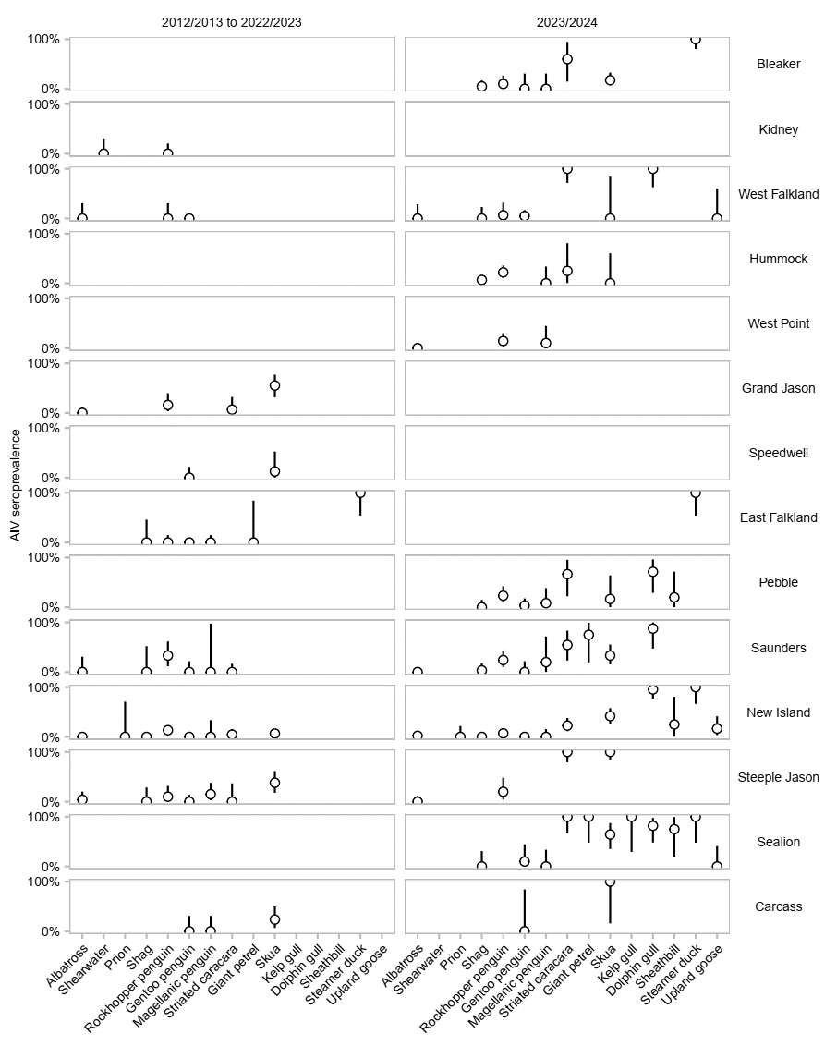

**Extended Data Figure 1.** **AIV seroprevalences in adult birds of the Falklands detailed per species, island and year.** Seroprevalences [95% credible intervals] were calculated as the proportion of samples positive for anti-AIV antibodies within a given population based on observed data (2,529 samples).

**Extended Data Figure 2.** **H5 seroprevalences in adult birds of the Falklands detailed per species, island and year.** Seroprevalences [95% credible intervals] were calculated as the proportion of samples positive for anti-H5 antibodies within a given population based on observed (white, 480 samples tested for anti-AIV and anti-H5 antibodies) or reconstructed (black, 2,049 samples tested for anti-AIV antibodies only) data.

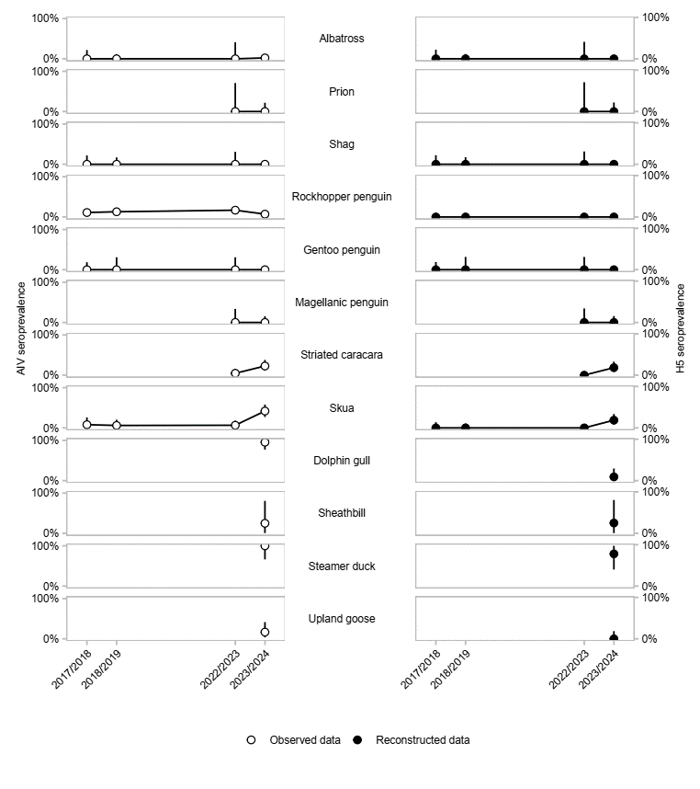

**Extended Data Figure 3.** **AIV and H5 seroprevalences in adult birds of New Island detailed per species and year.** Seroprevalences [95% credible intervals] were calculated as the proportion of samples positive for antibodies within a given population based on observed (white, 1,061 samples tested for anti-AIV antibodies) or reconstructed (black, including 157 samples tested for anti-H5 antibodies and 904 samples tested for anti-AIV antibodies only) data.

**Extended Data Figure 4.** **AIV and H5 seroprevalences in chicks of New Island detailed per species and year.** Seroprevalences [95% credible intervals] were calculated as the proportion of samples positive for antibodies within a given population based on observed (white, 137 samples tested for anti-AIV antibodies) or reconstructed (black, including 17 samples tested for anti-H5 antibodies and 120 samples tested for anti-AIV antibodies only) data.

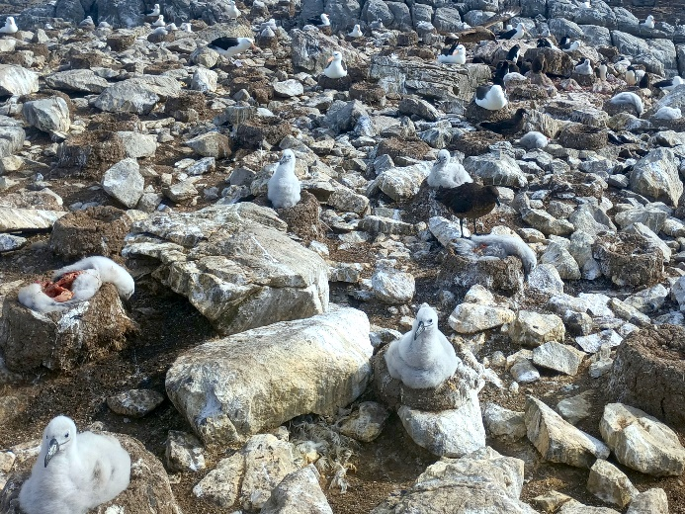

**Extended Data Figure 5. Apex predators scavenging during HPAI outbreaks.** Three skuas (left) and a striated caracara (right) scavenging on carrion in albatross colonies affected by H5N1 HPAI on Steeple Jason Island in January 2024. Copyrights: Julia Emerit.

**Extended Data Figure 6.** **Description of Sealion Island HPAI outbreak.** Combined AIV and H5 serostatuses for basal predators (shags, gentoo penguins and Magellanic penguins), apex predators (striated caracaras, skuas kelp gulls, dolphin gulls and sheathbills) and anatids (steamer ducks and upland geese) in 2023/2024 during an HPAI H5Nx outbreak. Each point represents a sample at its collection location. The crosse indicates where a cluster of dead birds (gentoo penguins) was observed.

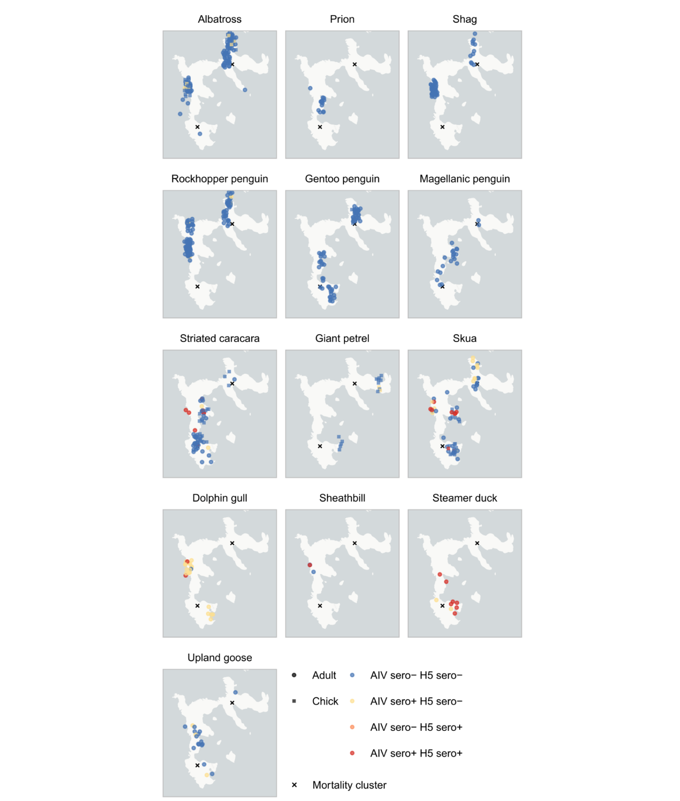

**Extended Data Figure 7.** **Description of New Island situation.** Combined AIV and H5 serostatuses for basal predators (shags, gentoo penguins and Magellanic penguins), apex predators (striated caracaras, skuas kelp gulls, dolphin gulls and sheathbills) and anatids (steamer ducks and upland geese) in 2023/2024. Each point represents a sample at its collection location. The crosses indicate where cluster of dead birds (skuas and gentoo penguins) were observed. No HPAI H5Nx outbreak had been detected there though, only individual cases in skuas23.

**Extended Data Figure 8.** **Monthly H5 seroprevalence in a resident and a migratory apex predator species.** Striated caracaras are year-long resident of the Falklands, hence could only be exposed to H5Nx within the archipelago. Skuas spend winter at sea north of the archipelago and come back for the breeding season mid-October each year and could thus be exposed to H5Nx either in winter out of the archipelago (in which case they would come back seropositive) or in summer within the archipelago.Seroprevalences [95% credible intervals] were calculated as the proportion of samples positive for antibodies within a given population based on reconstructed data. To avoid a confounding effect between time and location, we excluded islands where HPAI H5N1 outbreaks have been recorded (seroprevalences over the months during which those islands where visited would be inflated; see **Figure 5**).

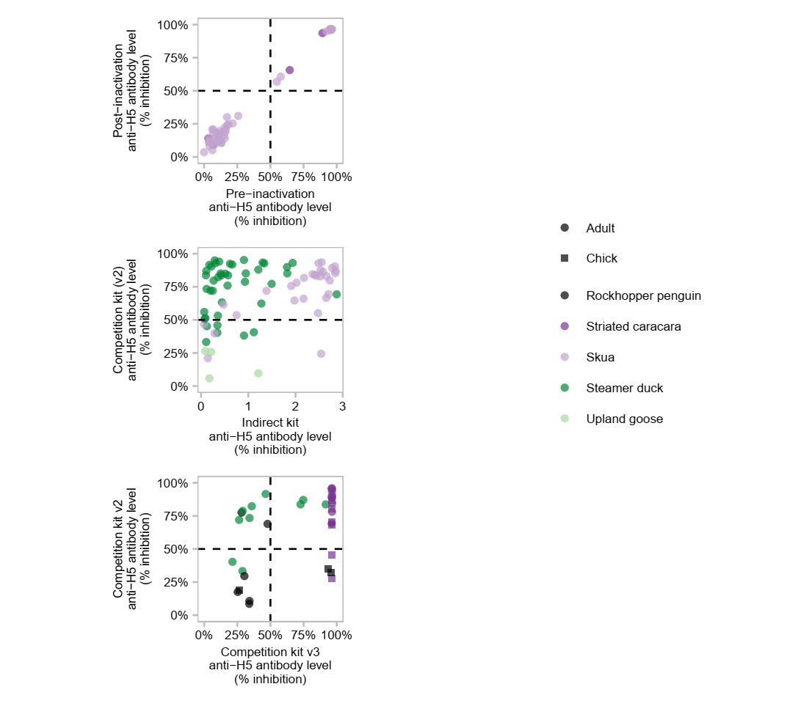

**Extended Data Figure 9.Immunoassay validation for anti-H5 antibody detection.** **Top**. Assessment of the impact of heat-inactivation on the ELISA outcomes. Samples were screened for anti-H5 antibodies using the competitive (v2) ELISA kit before and after inactivation at 30 min at 56°C. Linear regression r2 = 0.99. **Middle**. Comparison of the competition (v2) and indirect ELISA kits. **Bottom**. Comparison of the versions 2 and 3 ELISA kits. The dashed lines indicate the positivity threshold for anti-H5 antibody detection. The three assays differ in several ways, making it challenging to interpret potential inconsistencies. Indirect assays detect immunoglobulin Y (IgY) only, while competition assays also detect immunoglobulin M (IgM), which are produced earlier over the course of infection, and fade faster. The indirect kit we used uses as antigen a recombinant H5 protein from clade 2.3.4.4b. Competition v2 and v3 both use a monoclonal competitive antibody but v2 uses as antigen a whole virus from clade 2.2 while v3 uses a recombinant H5 protein from clade 2.3.4.4b, hence v3 is expected to be more specific for the current HPAI H5Nx panzootic lineage. We can however identify some species-specific patterns aligning with the epidemiological data. Striated caracaras and skuas, which, based on the rest of the data, were likely recently exposed to H5N1 2.3.4.4b, show relatively consistent results across assays with high antibody levels for all three considered assays. The steamer ducks, however, were likely exposed to an older H5Nx strain, which could explain the higher antibody levels detected with the competition v2 kit compared to both the indirect and competition v3 kits, which both used more recent antigens.

**Extended Data Table 1. AIV and** **H5 seroprevalences in adult birds of the Falklands detailed per species, island and year.** Seroprevalences [95% credible intervals] were calculated as the proportion of samples positive for antibodies within a given population based on observed (AIV seroprevalences) or reconstructed (H5 seroprevalences) data.

|  |  |  |  |  |  |
| --- | --- | --- | --- | --- | --- |
| **Year** | **Island** | **Species** | **Sample size** | **AIV seroprevalence (%)** | **H5 seroprevalence (%)** |
| 2012/2013 | Kidney | Shearwater | 10 | 0.00 [0.00, 30.85] | 0.00 [0.00, 30.85] |
| 2012/2013 | Kidney | Rockhopper penguin | 16 | 0.00 [0.00, 20.59] | 0.00 [0.00, 20.59] |
| 2012/2013 | West Falkland | Albatross | 10 | 0.00 [0.00, 30.85] | 0.00 [0.00, 30.85] |
| 2012/2013 | West Falkland | Rockhopper penguin | 10 | 0.00 [0.00, 30.85] | 0.00 [0.00, 30.85] |
| 2012/2013 | West Falkland | Gentoo penguin | 41 | 0.00 [0.00, 8.60] | 0.00 [0.00, 8.60] |
| 2012/2013 | Speedwell | Gentoo penguin | 15 | 0.00 [0.00, 21.80] | 0.00 [0.00, 21.80] |
| 2012/2013 | Speedwell | Skua | 8 | 12.50 [0.32, 52.65] | 0.00 [0.00, 36.94] |
| 2012/2013 | East Falkland | Rockhopper penguin | 13 | 0.00 [0.00, 24.71] | 0.00 [0.00, 24.71] |
| 2012/2013 | East Falkland | Gentoo penguin | 47 | 0.00 [0.00, 7.55] | 0.00 [0.00, 7.55] |
| 2012/2013 | East Falkland | Magellanic penguin | 23 | 0.00 [0.00, 14.82] | 0.00 [0.00, 14.82] |
| 2012/2013 | East Falkland | Giant petrel | 2 | 0.00 [0.00, 84.19] | 0.00 [0.00, 84.19] |
| 2012/2013 | Saunders | Albatross | 10 | 0.00 [0.00, 30.85] | 0.00 [0.00, 30.85] |
| 2012/2013 | Saunders | Shag | 5 | 0.00 [0.00, 52.18] | 0.00 [0.00, 52.18] |
| 2012/2013 | Saunders | Rockhopper penguin | 15 | 33.33 [11.82, 61.62] | 13.33 [1.66, 40.46] |
| 2012/2013 | Saunders | Gentoo penguin | 15 | 0.00 [0.00, 21.80] | 0.00 [0.00, 21.80] |
| 2012/2013 | Saunders | Magellanic penguin | 1 | 0.00 [0.00, 97.50] | 0.00 [0.00, 97.50] |
| 2012/2013 | Carcass | Gentoo penguin | 10 | 0.00 [0.00, 30.85] | 0.00 [0.00, 30.85] |
| 2012/2013 | Carcass | Magellanic penguin | 10 | 0.00 [0.00, 30.85] | 0.00 [0.00, 30.85] |
| 2012/2013 | Carcass | Skua | 17 | 23.53 [6.81, 49.90] | 0.00 [0.00, 19.51] |
| 2017/2018 | New Island | Albatross | 15 | 0.00 [0.00, 21.80] | 0.00 [0.00, 21.80] |
| 2017/2018 | New Island | Shag | 15 | 0.00 [0.00, 21.80] | 0.00 [0.00, 21.80] |
| 2017/2018 | New Island | Rockhopper penguin | 90 | 11.11 [5.46, 19.49] | 0.00 [0.00, 4.02] |
| 2017/2018 | New Island | Gentoo penguin | 18 | 0.00 [0.00, 18.53] | 0.00 [0.00, 18.53] |
| 2017/2018 | New Island | Skua | 25 | 8.00 [0.98, 26.03] | 0.00 [0.00, 13.72] |
| 2018/2019 | New Island | Albatross | 30 | 0.00 [0.00, 11.57] | 0.00 [0.00, 11.57] |
| 2018/2019 | New Island | Shag | 20 | 0.00 [0.00, 16.84] | 0.00 [0.00, 16.84] |
| 2018/2019 | New Island | Rockhopper penguin | 100 | 13.00 [7.11, 21.20] | 0.00 [0.00, 3.62] |
| 2018/2019 | New Island | Gentoo penguin | 10 | 0.00 [0.00, 30.85] | 0.00 [0.00, 30.85] |
| 2018/2019 | New Island | Skua | 33 | 6.06 [0.74, 20.23] | 0.00 [0.00, 10.58] |
| 2022/2023 | Grand Jason | Albatross | 30 | 0.00 [0.00, 11.57] | 0.00 [0.00, 11.57] |
| 2022/2023 | Grand Jason | Rockhopper penguin | 19 | 15.79 [3.38, 39.58] | 5.26 [0.13, 26.03] |
| 2022/2023 | Grand Jason | Striated caracara | 15 | 6.67 [0.17, 31.95] | 0.00 [0.00, 21.80] |
| 2022/2023 | Grand Jason | Skua | 20 | 55.00 [31.53, 76.94] | 0.00 [0.00, 16.84] |
| 2022/2023 | East Falkland | Shag | 6 | 0.00 [0.00, 45.93] | 0.00 [0.00, 45.93] |
| 2022/2023 | East Falkland | Rockhopper penguin | 10 | 0.00 [0.00, 30.85] | 0.00 [0.00, 30.85] |
| 2022/2023 | East Falkland | Steamer duck | 6 | 100.00 [54.07, 100.00] | 100.00 [54.07, 100.00] |
| 2022/2023 | Saunders | Striated caracara | 20 | 0.00 [0.00, 16.84] | 0.00 [0.00, 16.84] |
| 2022/2023 | New Island | Albatross | 7 | 0.00 [0.00, 40.96] | 0.00 [0.00, 40.96] |
| 2022/2023 | New Island | Prion | 3 | 0.00 [0.00, 70.76] | 0.00 [0.00, 70.76] |
| 2022/2023 | New Island | Shag | 10 | 0.00 [0.00, 30.85] | 0.00 [0.00, 30.85] |
| 2022/2023 | New Island | Rockhopper penguin | 77 | 16.88 [9.31, 27.14] | 0.00 [0.00, 4.68] |
| 2022/2023 | New Island | Gentoo penguin | 10 | 0.00 [0.00, 30.85] | 0.00 [0.00, 30.85] |
| 2022/2023 | New Island | Magellanic penguin | 9 | 0.00 [0.00, 33.63] | 0.00 [0.00, 33.63] |
| 2022/2023 | New Island | Striated caracara | 43 | 4.65 [0.57, 15.81] | 0.00 [0.00, 8.22] |
| 2022/2023 | New Island | Skua | 46 | 6.52 [1.37, 17.90] | 0.00 [0.00, 7.71] |
| 2022/2023 | Steeple Jason | Albatross | 25 | 4.00 [0.10, 20.35] | 0.00 [0.00, 13.72] |
| 2022/2023 | Steeple Jason | Shag | 11 | 0.00 [0.00, 28.49] | 0.00 [0.00, 28.49] |
| 2022/2023 | Steeple Jason | Rockhopper penguin | 20 | 10.00 [1.23, 31.70] | 5.00 [0.13, 24.87] |
| 2022/2023 | Steeple Jason | Gentoo penguin | 25 | 0.00 [0.00, 13.72] | 0.00 [0.00, 13.72] |
| 2022/2023 | Steeple Jason | Magellanic penguin | 20 | 15.00 [3.21, 37.89] | 0.00 [0.00, 16.84] |
| 2022/2023 | Steeple Jason | Striated caracara | 8 | 0.00 [0.00, 36.94] | 0.00 [0.00, 36.94] |
| 2022/2023 | Steeple Jason | Skua | 21 | 38.10 [18.11, 61.56] | 0.00 [0.00, 16.11] |
| 2023/2024 | Bleaker | Shag | 40 | 5.00 [0.61, 16.92] | 0.00 [0.00, 8.81] |
| 2023/2024 | Bleaker | Rockhopper penguin | 30 | 10.00 [2.11, 26.53] | 0.00 [0.00, 11.57] |
| 2023/2024 | Bleaker | Gentoo penguin | 10 | 0.00 [0.00, 30.85] | 0.00 [0.00, 30.85] |
| 2023/2024 | Bleaker | Magellanic penguin | 10 | 0.00 [0.00, 30.85] | 0.00 [0.00, 30.85] |
| 2023/2024 | Bleaker | Striated caracara | 5 | 60.00 [14.66, 94.73] | 20.00 [0.51, 71.64] |
| 2023/2024 | Bleaker | Skua | 40 | 17.50 [7.34, 32.78] | 5.00 [0.61, 16.92] |
| 2023/2024 | Bleaker | Steamer duck | 17 | 100.00 [80.49, 100.00] | 88.24 [63.56, 98.54] |
| 2023/2024 | West Falkland | Albatross | 11 | 0.00 [0.00, 28.49] | 0.00 [0.00, 28.49] |
| 2023/2024 | West Falkland | Shag | 14 | 0.00 [0.00, 23.16] | 0.00 [0.00, 23.16] |
| 2023/2024 | West Falkland | Rockhopper penguin | 15 | 6.67 [0.17, 31.95] | 0.00 [0.00, 21.80] |
| 2023/2024 | West Falkland | Gentoo penguin | 40 | 5.00 [0.61, 16.92] | 0.00 [0.00, 8.81] |
| 2023/2024 | West Falkland | Striated caracara | 11 | 100.00 [71.51, 100.00] | 72.73 [39.03, 93.98] |
| 2023/2024 | West Falkland | Skua | 2 | 0.00 [0.00, 84.19] | 0.00 [0.00, 84.19] |
| 2023/2024 | West Falkland | Dolphin gull | 8 | 100.00 [63.06, 100.00] | 37.50 [8.52, 75.51] |
| 2023/2024 | West Falkland | Upland goose | 4 | 0.00 [0.00, 60.24] | 0.00 [0.00, 60.24] |
| 2023/2024 | Hummock | Shag | 59 | 6.78 [1.88, 16.46] | 0.00 [0.00, 6.06] |
| 2023/2024 | Hummock | Rockhopper penguin | 50 | 22.00 [11.53, 35.96] | 6.00 [1.25, 16.55] |
| 2023/2024 | Hummock | Magellanic penguin | 9 | 0.00 [0.00, 33.63] | 0.00 [0.00, 33.63] |
| 2023/2024 | Hummock | Striated caracara | 4 | 25.00 [0.63, 80.59] | 25.00 [0.63, 80.59] |
| 2023/2024 | Hummock | Skua | 4 | 0.00 [0.00, 60.24] | 0.00 [0.00, 60.24] |
| 2023/2024 | West Point | Albatross | 45 | 0.00 [0.00, 7.87] | 0.00 [0.00, 7.87] |
| 2023/2024 | West Point | Rockhopper penguin | 35 | 14.29 [4.81, 30.26] | 2.86 [0.07, 14.92] |
| 2023/2024 | West Point | Magellanic penguin | 10 | 10.00 [0.25, 44.50] | 0.00 [0.00, 30.85] |
| 2023/2024 | East Falkland | Steamer duck | 6 | 100.00 [54.07, 100.00] | 83.33 [35.88, 99.58] |
| 2023/2024 | Pebble | Shag | 23 | 0.00 [0.00, 14.82] | 0.00 [0.00, 14.82] |
| 2023/2024 | Pebble | Rockhopper penguin | 30 | 23.33 [9.93, 42.28] | 3.33 [0.08, 17.22] |
| 2023/2024 | Pebble | Gentoo penguin | 29 | 3.45 [0.09, 17.76] | 0.00 [0.00, 11.94] |
| 2023/2024 | Pebble | Magellanic penguin | 12 | 8.33 [0.21, 38.48] | 0.00 [0.00, 26.46] |
| 2023/2024 | Pebble | Striated caracara | 6 | 66.67 [22.28, 95.67] | 66.67 [22.28, 95.67] |
| 2023/2024 | Pebble | Skua | 6 | 16.67 [0.42, 64.12] | 0.00 [0.00, 45.93] |
| 2023/2024 | Pebble | Dolphin gull | 7 | 71.43 [29.04, 96.33] | 28.57 [3.67, 70.96] |
| 2023/2024 | Pebble | Sheathbill | 5 | 20.00 [0.51, 71.64] | 0.00 [0.00, 52.18] |
| 2023/2024 | Saunders | Albatross | 40 | 0.00 [0.00, 8.81] | 0.00 [0.00, 8.81] |
| 2023/2024 | Saunders | Shag | 29 | 3.45 [0.09, 17.76] | 0.00 [0.00, 11.94] |
| 2023/2024 | Saunders | Rockhopper penguin | 29 | 24.14 [10.30, 43.54] | 0.00 [0.00, 11.94] |
| 2023/2024 | Saunders | Gentoo penguin | 15 | 0.00 [0.00, 21.80] | 0.00 [0.00, 21.80] |
| 2023/2024 | Saunders | Magellanic penguin | 5 | 20.00 [0.51, 71.64] | 0.00 [0.00, 52.18] |
| 2023/2024 | Saunders | Striated caracara | 11 | 54.55 [23.38, 83.25] | 18.18 [2.28, 51.78] |
| 2023/2024 | Saunders | Giant petrel | 4 | 75.00 [19.41, 99.37] | 75.00 [19.41, 99.37] |
| 2023/2024 | Saunders | Skua | 24 | 33.33 [15.63, 55.32] | 4.17 [0.11, 21.12] |
| 2023/2024 | Saunders | Dolphin gull | 8 | 87.50 [47.35, 99.68] | 62.50 [24.49, 91.48] |
| 2023/2024 | New Island | Albatross | 90 | 2.22 [0.27, 7.80] | 0.00 [0.00, 4.02] |
| 2023/2024 | New Island | Prion | 15 | 0.00 [0.00, 21.80] | 0.00 [0.00, 21.80] |
| 2023/2024 | New Island | Shag | 55 | 0.00 [0.00, 6.49] | 0.00 [0.00, 6.49] |
| 2023/2024 | New Island | Rockhopper penguin | 113 | 7.08 [3.11, 13.47] | 0.00 [0.00, 3.21] |
| 2023/2024 | New Island | Gentoo penguin | 65 | 0.00 [0.00, 5.52] | 0.00 [0.00, 5.52] |
| 2023/2024 | New Island | Magellanic penguin | 22 | 0.00 [0.00, 15.44] | 0.00 [0.00, 15.44] |
| 2023/2024 | New Island | Striated caracara | 44 | 22.73 [11.47, 37.84] | 18.18 [8.19, 32.71] |
| 2023/2024 | New Island | Skua | 43 | 41.86 [27.01, 57.87] | 18.60 [8.39, 33.40] |
| 2023/2024 | New Island | Dolphin gull | 22 | 95.45 [77.16, 99.88] | 9.09 [1.12, 29.16] |
| 2023/2024 | New Island | Sheathbill | 4 | 25.00 [0.63, 80.59] | 25.00 [0.63, 80.59] |
| 2023/2024 | New Island | Steamer duck | 9 | 100.00 [66.37, 100.00] | 77.78 [39.99, 97.19] |
| 2023/2024 | New Island | Upland goose | 18 | 16.67 [3.58, 41.42] | 0.00 [0.00, 18.53] |
| 2023/2024 | Steeple Jason | Albatross | 30 | 0.00 [0.00, 11.57] | 0.00 [0.00, 11.57] |
| 2023/2024 | Steeple Jason | Rockhopper penguin | 15 | 20.00 [4.33, 48.09] | 6.67 [0.17, 31.95] |
| 2023/2024 | Steeple Jason | Striated caracara | 16 | 100.00 [79.41, 100.00] | 100.00 [79.41, 100.00] |
| 2023/2024 | Steeple Jason | Skua | 20 | 100.00 [83.16, 100.00] | 95.00 [75.13, 99.87] |
| 2023/2024 | Sealion | Shag | 10 | 0.00 [0.00, 30.85] | 0.00 [0.00, 30.85] |
| 2023/2024 | Sealion | Gentoo penguin | 10 | 10.00 [0.25, 44.50] | 0.00 [0.00, 30.85] |
| 2023/2024 | Sealion | Magellanic penguin | 9 | 0.00 [0.00, 33.63] | 0.00 [0.00, 33.63] |
| 2023/2024 | Sealion | Striated caracara | 9 | 100.00 [66.37, 100.00] | 100.00 [66.37, 100.00] |
| 2023/2024 | Sealion | Giant petrel | 5 | 100.00 [47.82, 100.00] | 20.00 [0.51, 71.64] |
| 2023/2024 | Sealion | Skua | 14 | 64.29 [35.14, 87.24] | 42.86 [17.66, 71.14] |
| 2023/2024 | Sealion | Kelp gull | 3 | 100.00 [29.24, 100.00] | 66.67 [9.43, 99.16] |
| 2023/2024 | Sealion | Dolphin gull | 11 | 81.82 [48.22, 97.72] | 36.36 [10.93, 69.21] |
| 2023/2024 | Sealion | Sheathbill | 4 | 75.00 [19.41, 99.37] | 0.00 [0.00, 60.24] |
| 2023/2024 | Sealion | Steamer duck | 5 | 100.00 [47.82, 100.00] | 60.00 [14.66, 94.73] |
| 2023/2024 | Sealion | Upland goose | 7 | 0.00 [0.00, 40.96] | 0.00 [0.00, 40.96] |
| 2023/2024 | Carcass | Gentoo penguin | 2 | 0.00 [0.00, 84.19] | 0.00 [0.00, 84.19] |
| 2023/2024 | Carcass | Skua | 2 | 100.00 [15.81, 100.00] | 0.00 [0.00, 84.19] |

**Extended Data Table 2. AIV and** **H5 seroprevalences in chicks of the Falklands detailed per species, island and year.** Seroprevalences [95% credible intervals] were calculated as the proportion of samples positive for antibodies within a given population based on observed (AIV seroprevalences) or reconstructed (H5 seroprevalences) data.

|  |  |  |  |  |  |
| --- | --- | --- | --- | --- | --- |
| **Year** | **Island** | **Species** | **Sample size** | **AIV seroprevalence (%)** | **H5 seroprevalence (%)** |
| 2017/2018 | New Island | Shag | 5 | 0.00 [0.00, 52.18] | 0.00 [0.00, 52.18] |
| 2017/2018 | New Island | Skua | 5 | 0.00 [0.00, 52.18] | 0.00 [0.00, 52.18] |
| 2022/2023 | New Island | Albatross | 6 | 0.00 [0.00, 45.93] | 0.00 [0.00, 45.93] |
| 2022/2023 | New Island | Shag | 5 | 0.00 [0.00, 52.18] | 0.00 [0.00, 52.18] |
| 2022/2023 | New Island | Striated caracara | 17 | 0.00 [0.00, 19.51] | 0.00 [0.00, 19.51] |
| 2023/2024 | Bleaker | Giant petrel | 20 | 0.00 [0.00, 16.84] | 0.00 [0.00, 16.84] |
| 2023/2024 | Bleaker | Skua | 20 | 0.00 [0.00, 16.84] | 0.00 [0.00, 16.84] |
| 2023/2024 | West Falkland | Albatross | 13 | 0.00 [0.00, 24.71] | 0.00 [0.00, 24.71] |
| 2023/2024 | Saunders | Albatross | 10 | 10.00 [0.25, 44.50] | 0.00 [0.00, 30.85] |
| 2023/2024 | Saunders | Skua | 3 | 0.00 [0.00, 70.76] | 0.00 [0.00, 70.76] |
| 2023/2024 | New Island | Albatross | 45 | 11.11 [3.71, 24.05] | 0.00 [0.00, 7.87] |
| 2023/2024 | New Island | Gentoo penguin | 6 | 0.00 [0.00, 45.93] | 0.00 [0.00, 45.93] |
| 2023/2024 | New Island | Striated caracara | 16 | 0.00 [0.00, 20.59] | 0.00 [0.00, 20.59] |
| 2023/2024 | New Island | Giant petrel | 15 | 13.33 [1.66, 40.46] | 0.00 [0.00, 21.80] |
| 2023/2024 | New Island | Skua | 17 | 17.65 [3.80, 43.43] | 5.88 [0.15, 28.69] |
| 2023/2024 | Steeple Jason | Albatross | 30 | 0.00 [0.00, 11.57] | 0.00 [0.00, 11.57] |
| 2023/2024 | Steeple Jason | Rockhopper penguin | 15 | 20.00 [4.33, 48.09] | 0.00 [0.00, 21.80] |
| 2023/2024 | Steeple Jason | Striated caracara | 14 | 78.57 [49.20, 95.34] | 64.29 [35.14, 87.24] |
| 2023/2024 | Sealion | Gentoo penguin | 12 | 16.67 [2.09, 48.41] | 8.33 [0.21, 38.48] |
| 2023/2024 | Carcass | Gentoo penguin | 8 | 0.00 [0.00, 36.94] | 0.00 [0.00, 36.94] |
| 2023/2024 | Carcass | Skua | 3 | 0.00 [0.00, 70.76] | 0.00 [0.00, 70.76] |